**IoT Enabled Monitoring System**

***Stork***

**Semester 2 Report**

**Luke Halley**

**20071820**

**Panel Number 6**

**Supervisor: Mr. Joe Daly**

**Second Reader: Mr. Robert O' Connor**

**Third Reader: Dr. T.J. McDonald**

**Fourth Reader: Mr. Richard Lacey**

**BSc (Hons) in The Internet Of Things**

# 

# TABLE OF CONTENTS.

**TABLE OF CONTENTS.** **2**

**ABSTRACT.** **5**

**RESOURCES.** **6**

**THE PLAN DEVISED.** **7**

The User Case. 7

Creating the Stork Account. 7

Registering The Stork Device. 7

Setting Up The Stork Device. 8

Tracking ‘The Lacemaker’. 8

**THE PLAN IN ACTION.** **9**

Creating A Stork Account. 9

Registering The Stork Device. 10

Setting Up The Stork Device. 12

Tracking “The Lacemaker”. 13

**DEVELOPMENT ENVIRONMENT.** **14**

My Personal Machine. 14

Angular Essentials. 14

Pymakr. 14

Docker. 15

Ubuntu 18.04 Remote Server. 16

SFTP. 16

**IMPLEMENTATION.** **17**

Frontend. **17**

Designing Frontend. 19

CSS Framework. 23

Technologies Used. 25

Framework. 25

Components. 25

Ngif, Else & Ng Template. 27

Modules. 29

Auth Guards. 30

Form Validation. 33

Environment Variables. 35

RXJS. 36

Sweetalert2 & HttpInterceptor. 37

Typescript. 38

Backend. **39**

Technologies Used. 39

Bcrypt. 39

JSON Web Tokens. 39

Mongoose. 40

Environment Variables. 42

ExpressJS. 43

Middleware 44

APIs. **45**

Stork Devices. 45

Registered Stork. 45

Users. 45

Database. **46**

Collections. 46

Devices. 46

Storks. 47

Users. 48

Device. **49**

Libraries Used. 49

Startup. 49

Monitoring Loop. 50

Stork.ie Domain. 57

**SIGFOX BACKEND.** **58**

Callback Type. 58

Payload. 58

Url Pattern. 59

Callback Content. 59

**DOCKER.** **61**

Docker Compose. 61

Frontend Container. 62

Backend Container. 63

Database Container. 64

Makefile Usage. 65

**DEPLOYMENT.** **66**

**TESTING.** **67**

Implementation. 68

Setup. 68

Add Registerable Device. 70

User Signup Test. 70

User Login Test. 70

Stork Register Test. 71

Stork Edit Test. 72

Stork Delete Test. 72

User Logout Test. 73

Remove Registered Device. 73

Running Tests Using Gitlab Continuous Integration. 74

**PROJECT MANAGEMENT.** **78**

Issues. 79

Iterations. 80

Tags. 82

Stork Wiki. 83

**VERSION CONTROL.** **84**

Regular Commits. 84

Meaningful Commit Messages. 84

Development Branch. 84

Feature Branches. 85

**CHALLENGES.** **86**

Testing & Running Code On The Stork Device. 86

Laying Out The Stork Web Application. 86

Learning How To Implement JWT. 86

**CONCLUSION.** **87**

**Luke Halley**

20017280

BSc (Hons) in the Internet of Things

4th Year

**STORK.**

Final Year Project Report

28th April 2019

# ABSTRACT.

Combining hardware and software elements, Stork is the brand name of this unique IoT monitoring system. The hardware consists of the monitoring device itself while the processing, visualisation and management of the data being collected by the Stork unit, facilitated by the Stork web application.

The Stork device, is placed inside a parcel alongside an item for transportation. This unit, monitors the shipping of said parcel from its initial dispatch location, right through to its final delivery destination. Data is collected over the course of the parcel’s journey in intervals of 10 minutes. This information is then relayed to the owner of the Stork device over the Sigfox network.

This list of data which is collected by the device:

● current location using the Stork devices highly accurate GPS;

● current handling condition by interpreting readings from the Stork devices three axis accelerometer;

● current humidity and temperature readings within the parcel and its surrounding environment;

# RESOURCES.

The following links will provide additional information relevant to this report.

Stork Live Web Application: <http://stork.ie/>

Stork Web Service Repository: <https://gitlab.com/stork-group/stork-web-service>

Stork Device Service Repository: <https://gitlab.com/stork-group/stork-device-service>

Stork Demonstration Video: <https://youtu.be/NECp2ISX538>

# 

# THE PLAN DEVISED.

The vision for Stork was for it to be a complete and market ready system. A user case was created as part of my design document to illustrate this.

## The User Case.

Hugo Cortot is a manager at The Louvre, the world's largest art museum located in Paris, France.

The famous 16th century painting, The Lacemaker, is being sent to the Irish Museum of Modern Art in Dublin, Ireland. Hugo must ensure that this valuable painting arrives in Dublin safely, on time and in perfect condition.

Hugo purchases the Stork device on the online marketplace Amazon.co.uk for €50. Even though the museum uses the trusted art transportation services of Garron, Hugo wants further peace of mind by adding another layer of security in the transport journey of the painting. The key bonus of using the Stork device for Hugo, will be its ability to monitor the location and environmental conditions in which the painting is kept at all times. Given that this painting is priceless, the added cost is deemed negligible.

## Creating the Stork Account.

Hugo opens the Stork device packaging with the intention of setting up the device. He is first met with a small card containing a set of instructions as well as a URL to the Stork website which allows him to create a Stork user account. Hugo follows the guide and signs up for a Stork account by providing the details required.

## Registering The Stork Device.

Hugo then logs in and proceeds to add the device to the platform by entering the unique ID code printed on his instruction card. In addition, a nickname of his choosing, is assigned to the Stork device. After a short period of time, the Stork system verifies that the device is valid and available for registration. Hugo receives a message confirming that his device has been successfully set-up, is registered and is ready to use.

## Setting Up The Stork Device.

Hugo is then prompted to use the second instruction card where he is told to connect the Stork device to its battery. The remaining steps on the card once followed, ensures that the device sets itself up successfully and begins to monitor and track. Hugo finally secures the Stork device within the painting’s packaging. Within ten minutes, information is relayed from the Stork device to his personal Stork dashboard. The parcel is then closed and sent to Ireland.

## Tracking ‘The Lacemaker’.

Over the course of the painting’s transportation journey, Hugo can regularly check the parcel to see if it is: on route to Dublin; not being mishandled by the couriers; being transported in agreed environmental conditions.

# 

# THE PLAN IN ACTION.

By the end of the development cycle, the Stork system became fully functional and now has the potential to be brought to market.

The same user case will be used for the purpose of illustrating how Hugo Cortot tracked the painting ‘*The Lacemaker’* with the Stork system designed.

A full walkthrough of a how the Stork device is setup, registered is available here: [bit.ly/StorkDemoVideo](http://bit.ly/StorkDemoVideo). Timestamps are used e.g. [1:33] together with each heading and can be used to gain a greater understanding of the section in question.

## Creating A Stork Account.

[1:33]

When Hugo unboxes his Stork device, he is met with the first of two cards with instructions on setup and a URL for the Stork website (Figure 1).

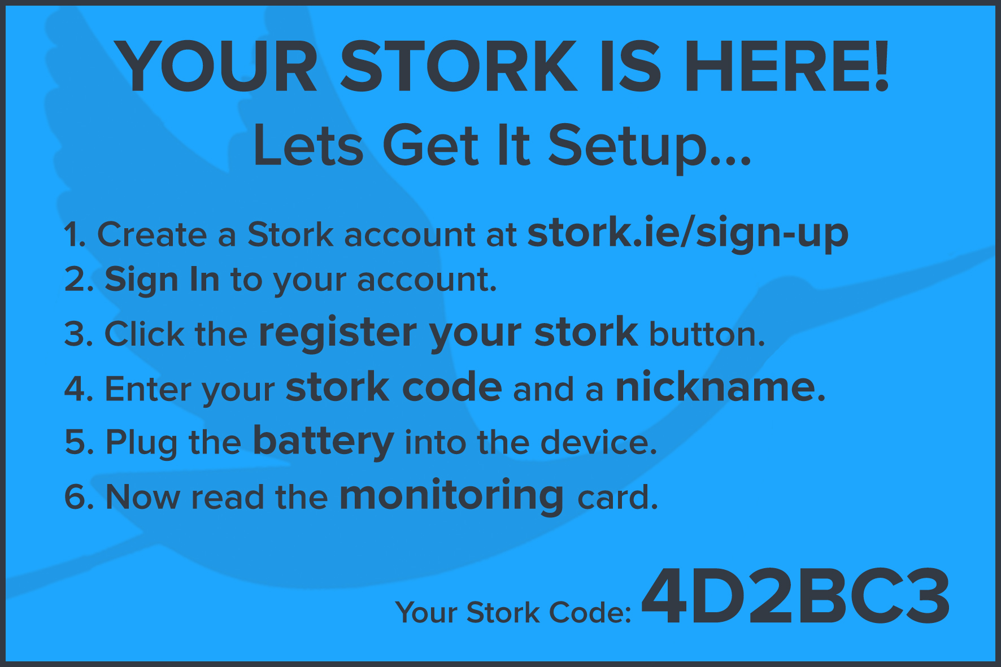

Figure 1: First Stork instruction card; setup

Hugo follows the first step of the above guide and navigates to **stork.ie/sign-up** where he creates his Stork account by providing the necessary details (Figure 2).

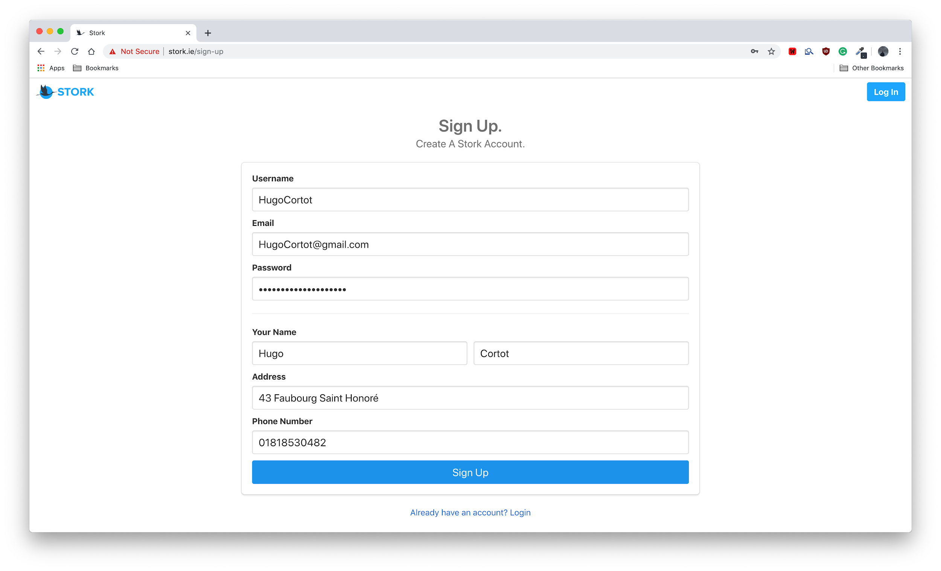

Figure 2: Stork sign up page

## Registering The Stork Device.

[2:02]

Hugo then logs in to the account he just created (Figure 3).

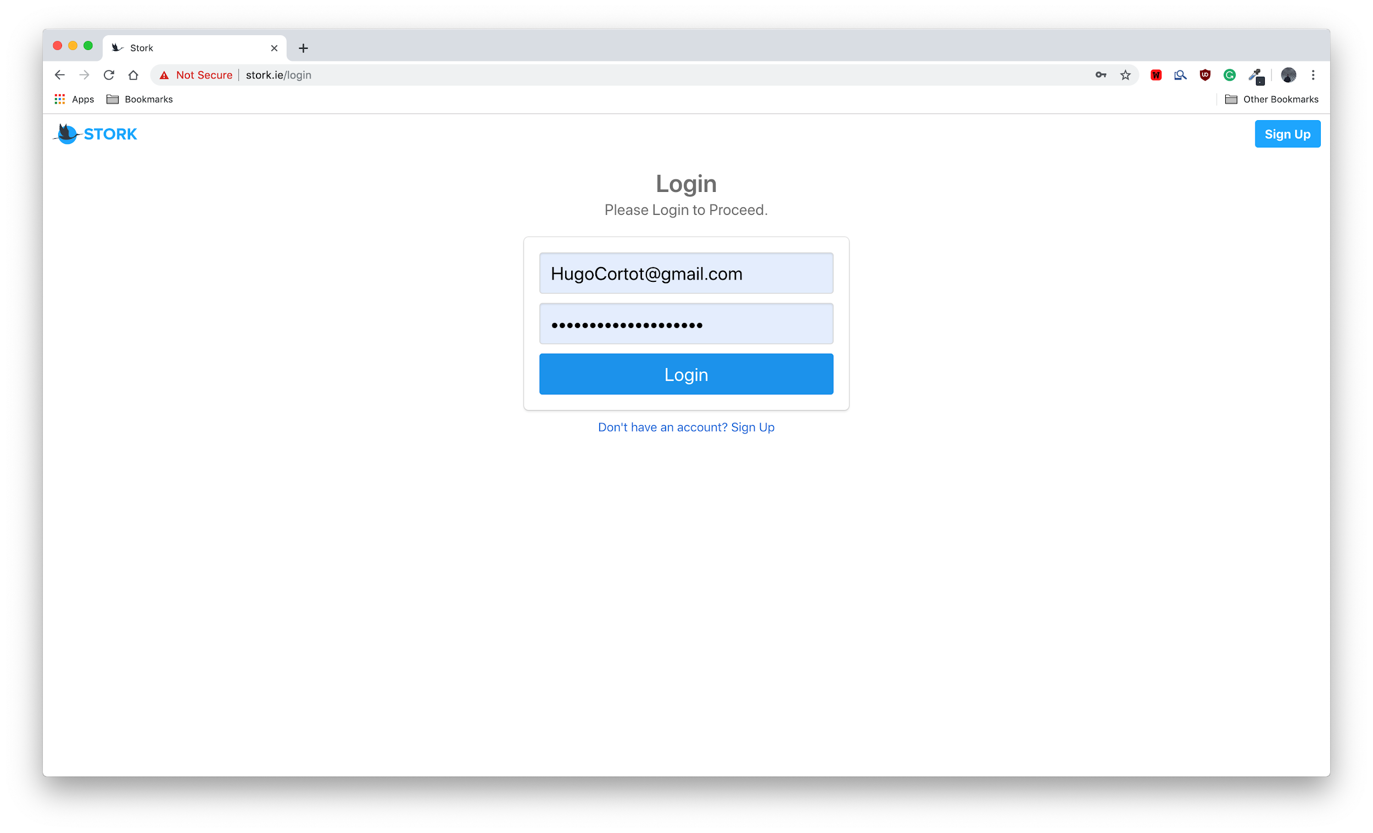

Figure 3: Stork login page

After the Stork system verifies that Hugo’s credentials are valid, he is navigated to the main page of the Stork dashboard where users track all their Stork devices. As expected, a message is displayed informing him he that he has no Stork device registered to his account yet (Figure 4).

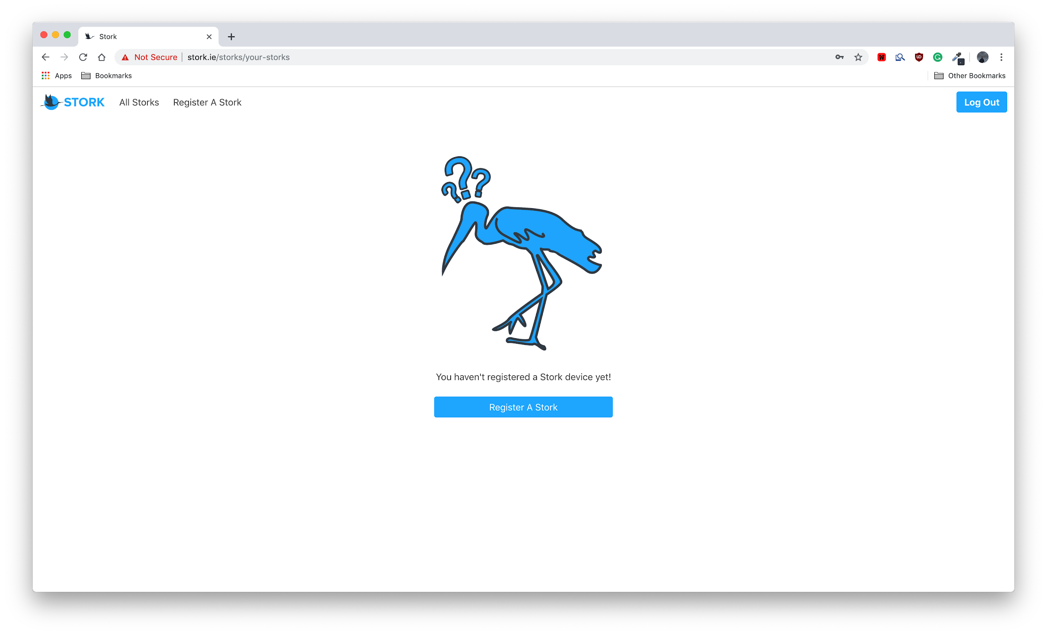

Figure 4: Stork tracking page

For the device to be added to Hugo’s account, it must be set as a **Registerable Device.** This can only be completed following purchase so as to ensure that fraudulent devices can not be added to the Stork system.

To add Hugo’s device as a **Registerable Device** Api is used (Figure 5). The device is now available for registration.

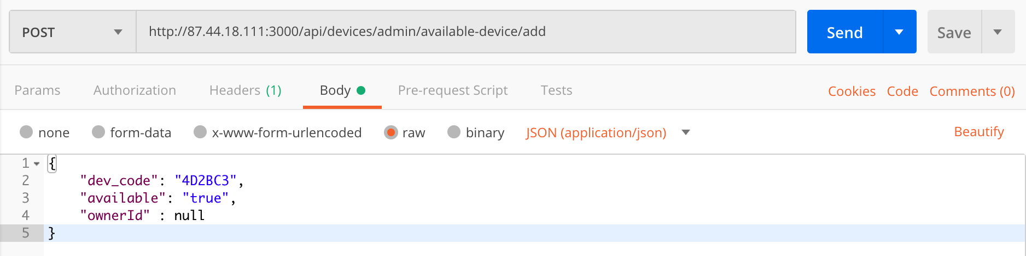

Figure 5: Using the Stork Api to add a registerable device.

For an in depth explanation of all API routes included in the Stork system (see page 44).

The output is as follows (Figure 6).

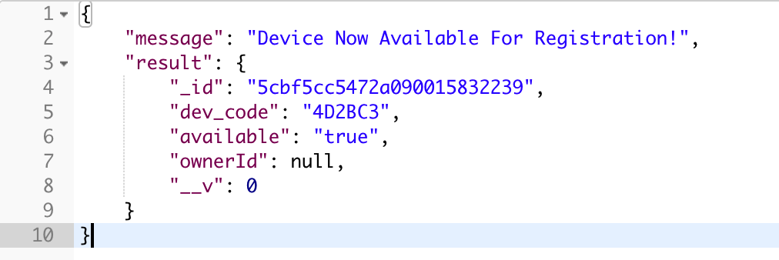

Figure 6: Result of the addition of a registerable device

Hugo then proceeds to click the **Register Your Stork** button which transfers him as the user, to the **tracking** section of the Stork Web Application. Here he enters the **Unique** **Stork Code** (located on the first Stork instruction card)and a **Nickname** of his choosing (Figure 7).

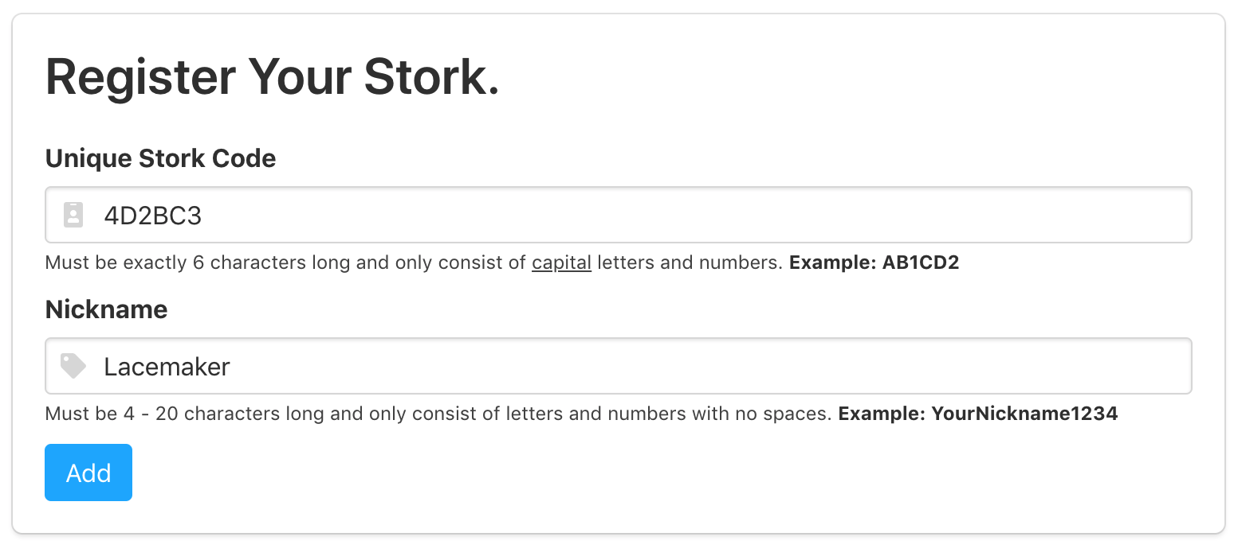

Figure 7: Stork device register form

After a few moments, the system verifies this as a registrable device and is added to Hugo’s account. After this, the browser navigates him back to the **tracking** section where the newly added device is recognised (Figure 8).

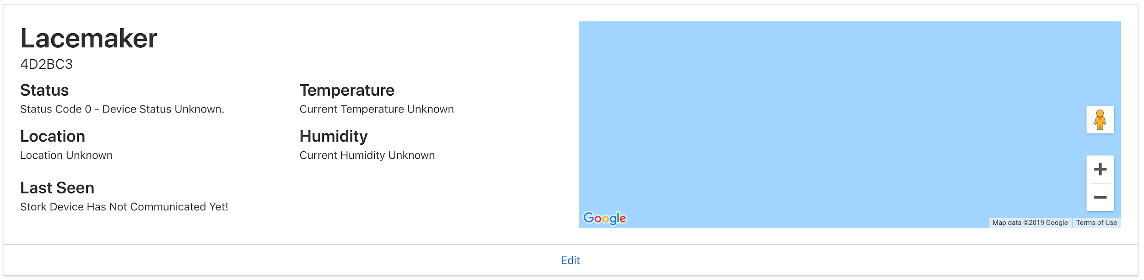

Figure 8: Successful Stork device registered.

## Setting Up The Stork Device.

[03:24]

Hugo is then prompted to move his attention to the second instruction card (Figure 9).

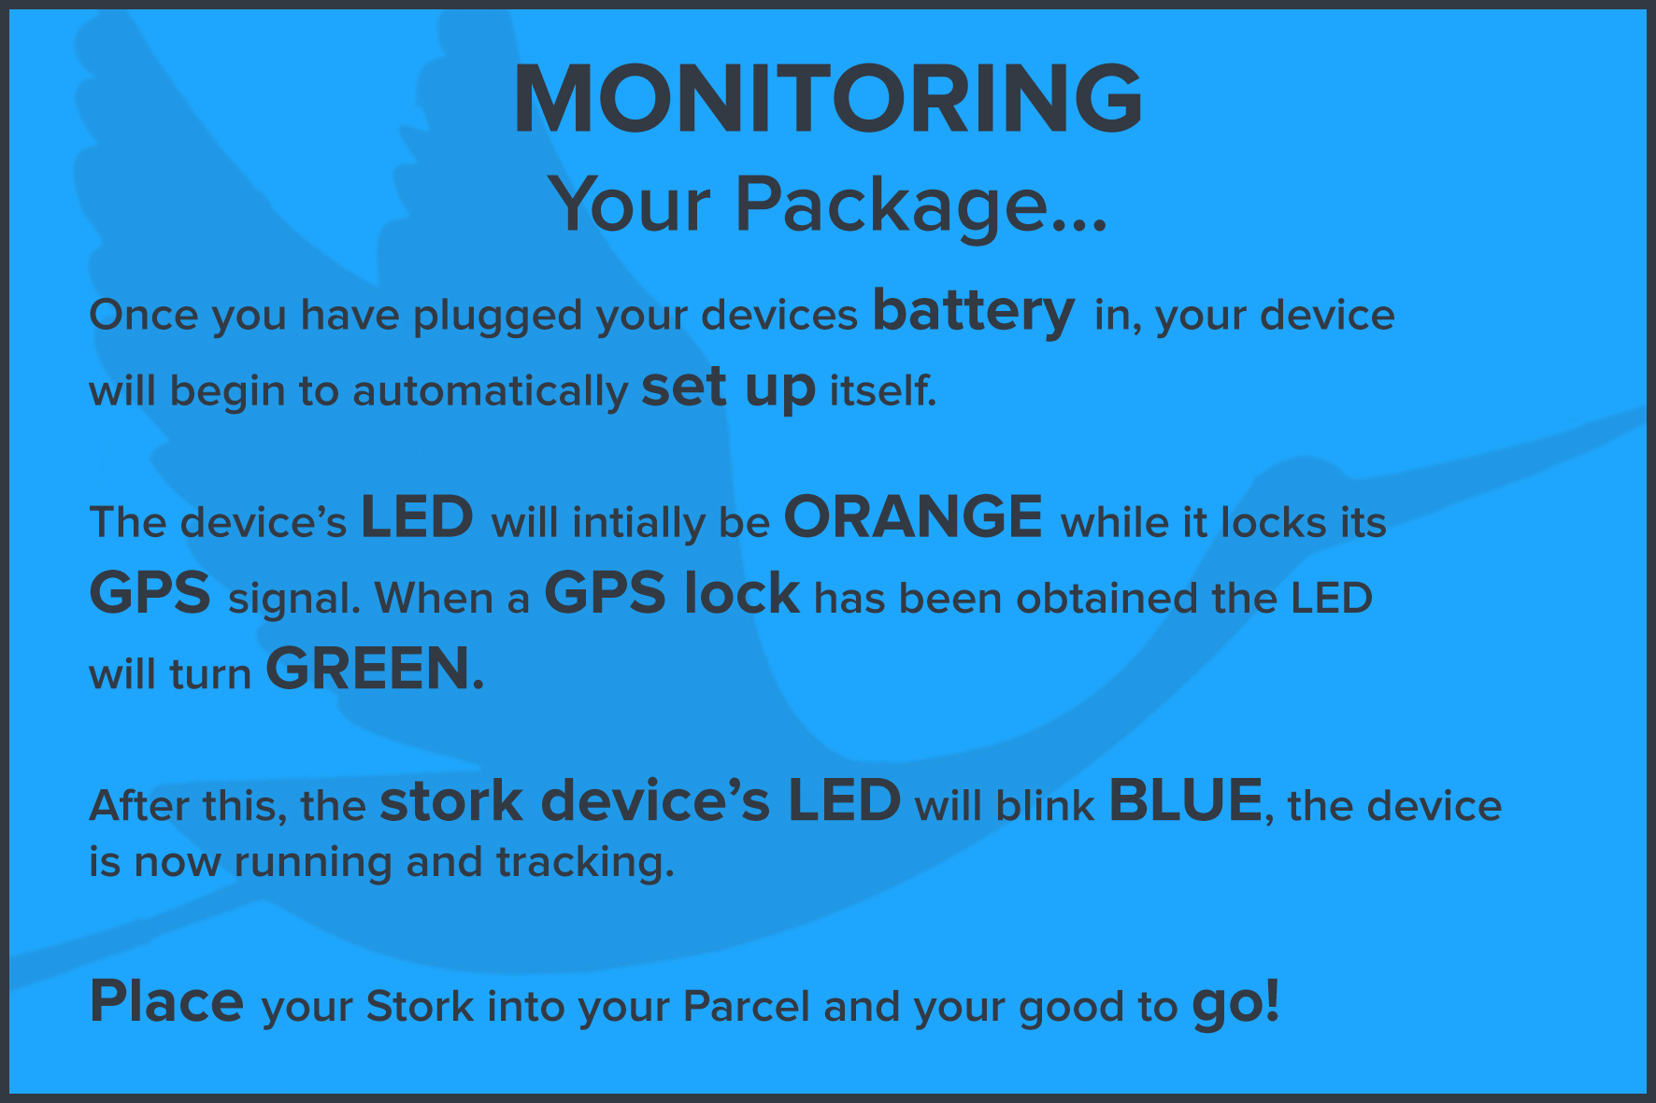

Figure 9: Second Stork instruction card; monitoring.

Here the user is instructed to connect the Stork device to its battery.

By following the remaining steps on the card, the device sets itself up successfully:

* The device’s LED first goes orange while its locking onto a GPS signal;
* After a few minutes, the LED turns green, indicating that a GPS signal has been locked;
* Approximately five seconds later, the LED began to blink blue, letting Hugo know that his Stork device is ready to use.

Now that Hugo has set up his device, he places the Stork device in its casing and secures it to the inside of the painting’s transportation packaging.

## Tracking “The Lacemaker”.

[06:31]

By the time Hugo has inserted the Stork device inside the painting’s packaging, the Stork device has already finished its first ten minute interval and sent data to the cloud. Hugo can already log into the Stork web application and view information relating to the parcel’s status, location, temperature and humidity (Figure 10). Taking a quick glance at his dashboard Hugo can see his device is tracking and monitoring the painting as expected.

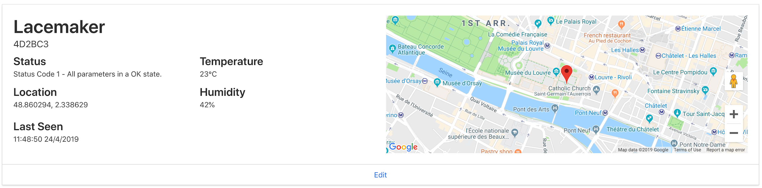

Figure 10: Tracking a Stork device.

# DEVELOPMENT ENVIRONMENT.

During the development cycle of Stork, there were two main elements to the development environment; **my personal machine (a Macbook Pro)** and Ubuntu 18.04 remote server.

## My Personal Machine.

A single editor for all development was chosen; Visual Studio Code, a source-code editor developed by Microsoft. This kept development simple and streamlined removing the need to switch back and forth between different programs as the project progressed. Visual Studio Code is highly configurable and as such, allows install **extensions** for all programming languages and libraries used as part of this project. The following section outlines three of the most useful packages (in no particular order) added to VSCode to aid in the the development of Stork.

### [Angular Essentials](https://github.com/johnpapa/vscode-angular-essentials).

Angular Essentials added a number of extensions that were extremely useful for the project’s Angular development. The main package which when applied and was very helpful was the [Angular Language Service](https://marketplace.visualstudio.com/items?itemName=Angular.ng-template). This provided inline code completion and allowed for a quick information read relating to the components of Angular without leaving the editor (Figure 11a).

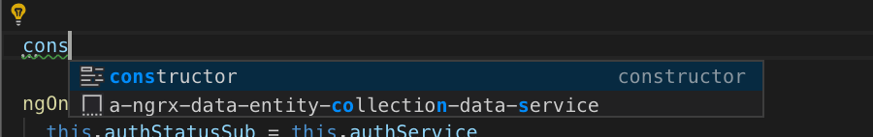

Figure 11a: Inline angular code completion

### [Pymakr](https://marketplace.visualstudio.com/items?itemName=pycom.Pymakr).

Pymakr placed a REPL console (see figure 11b) at the bottom of the text editor allowing for the interaction with a Stork device while writing code. The package was mainly used to run single micropython files on the board. Nearing the end of the development cycle, code was uploaded to the device which would then run every time the device was powered on (Figure 12).

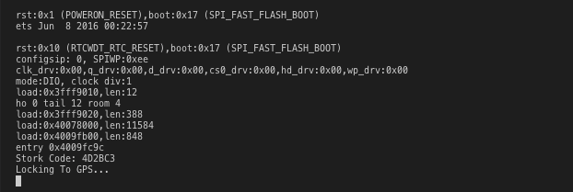

Figure 11b: Inline angular code completion

### [Docker](https://marketplace.visualstudio.com/items?itemName=PeterJausovec.vscode-docker).

The Docker package provided rich intellisense completions along with syntax highlighting during the creation and editing of the Dockerfiles and docker-compose.yml files. As the Stork system became more complex, this package facilitated the finding of docker related files to fix or alter if necessary. As a time saving tool, it avoided the constant building and tearing down of containers where an error was thrown near the end of a build. See the implementation section for more detail on how Docker worked.

### 

## Ubuntu 18.04 Remote Server.

For my third year flexible semester I completed an internship with Telecommunications Software and Systems Group (TSSG) as a full stack developer. At the end of my time there, my manager Dr. Miguel Ponce De Leon, kindly provided me with a remote server to use as part of my final year project.

### [SFTP](https://marketplace.visualstudio.com/items?itemName=liximomo.sftp).

In order to access, transfer and manage all the files on the server, the sftp package for Visual Studio Code was installed. This allowed for the set up of a SSH File Transfer Protocol between my personal machine and the server. Work on files could be completed locally in Visual Studio Code, any changes saved, quickly seen and mirrored on the server.

Initially, the set up was a little challenging, here are the steps taken to get it working. To configure the sftp package after it was installed, the following command palette was given (⌘ + SHIFT + P on macOs) and typed *‘sftp’* and click **SFTP: Config:** (Figure 13a).

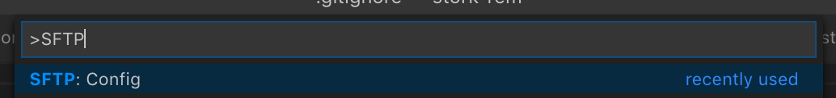

Figure 13a: Opening the sftp config using the command palette

Then transferred to a file called **sftp.json** used to configure the package (Figure 13b).

| {  "name": "Stork",  "protocol": "sftp",  "host": "87.44.18.111",  "username": "ubuntu",  "remotePath": "/home/ubuntu/stork-web-service/",  "privateKeyPath": "<PATH TO YOUR LOCAL PRIVATE KEY>",  "uploadOnSave": true,  "watcher": {  "files": "**/*",  "autoUpload": true,  "autoDelete": true  },  "ignore": ["**/.vscode/**", "**/.DS_Store/**", "**/.git/**"] } |
| --- |

Figure 13b: Stork sftp config

The command palette was reopened and synced the current file system with my local file system (Figure 14). From then onwards it worked seamlessly.

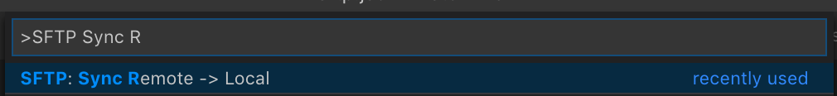

Figure 14: Syncing file system with Stork server using the command palette

# IMPLEMENTATION.

* **Frontend**: Client-side development and technologies;
* **Backend**: Logical and underlying technology development and technologies;
* **Database**: Configuration and management of Stork data;
* **Device:** Setup & programming of the Stork device;
* **Docker**: Containerization of the Stork system;
* **Testing**: Stork testing strategy.

## Frontend.

The frontend of the Stork system was based on a concept of the Storks Web Application created from the design stage of the Stork project (Figure 15).

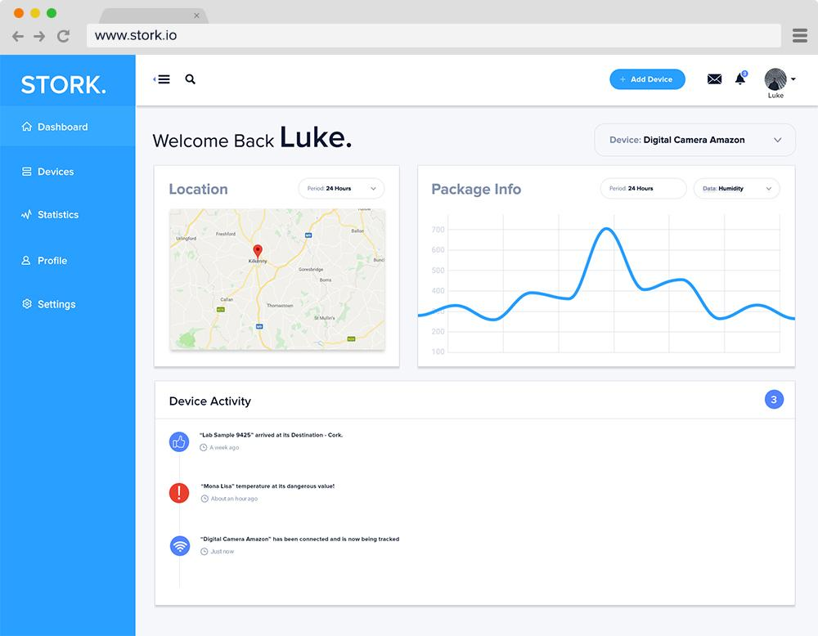

Figure 15: Stork web application concept design

### Designing Frontend.

While the initial concept helped visualise a design layout, I created a number of user stories and developed the frontend based on these to ensure that the Stork’s interface was clear and user friendly. I focused on what the user needed to be able to view and do on the Stork Web Application.

Two user stories from the Stork Web Service Wiki are used here to demonstrate how they aided the development of the Frontend of Stork. A full list of all users stories is available at [bit.ly/StorkUserStories](http://bit.ly/StorkUserStories).

Below is an example which illustrates how a user successfully signs up for a Stork account using valid credentials by filling in all required fields. This was used to create both the **register** and **sign up** page. The process involves going through each step and implementing what was needed to allow a user to perform that task (Figure 16)..

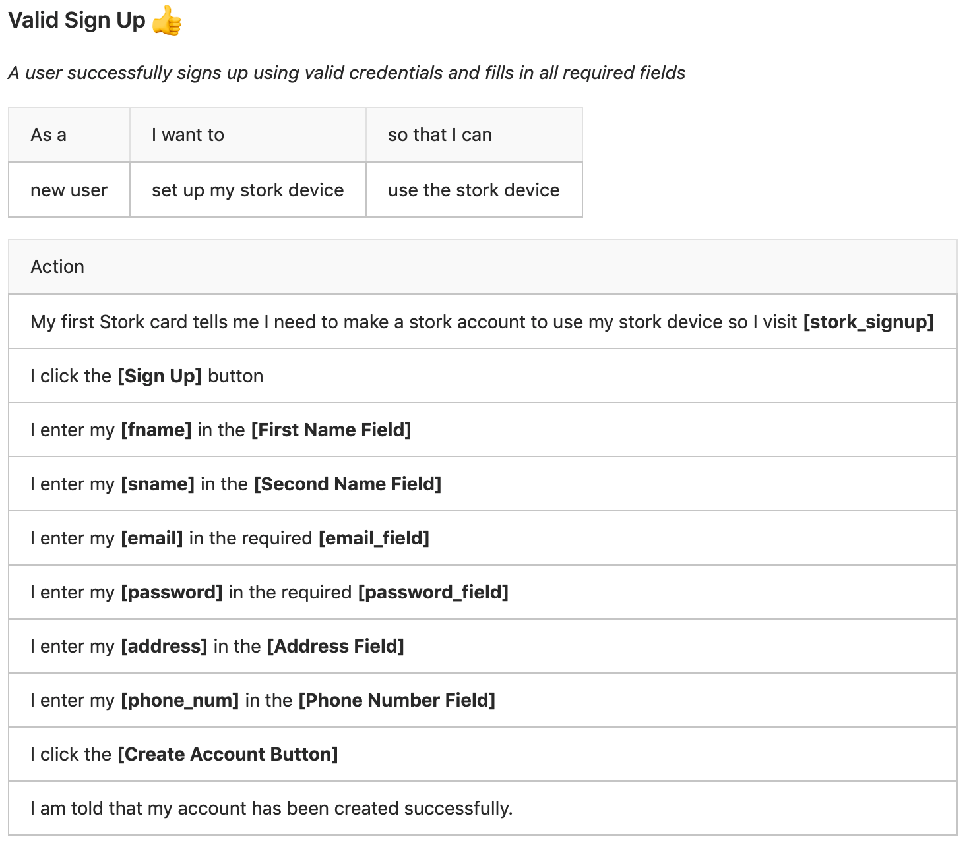

Figure 16: Valid sign up user story

Having worked through all user account stories handling a user both successfully and unsuccessfully signing up for a Stork user account; a user both successfully and unsuccessfully logging in to their Stork account, the sign up page and login page were created (Figures 17 and 18).

Stork **Sign Up** Page - <http://stork.ie/sign-up>

## 

Figure 17: Stork sign up page

Stork **Login** Page - <http://stork.ie/login>

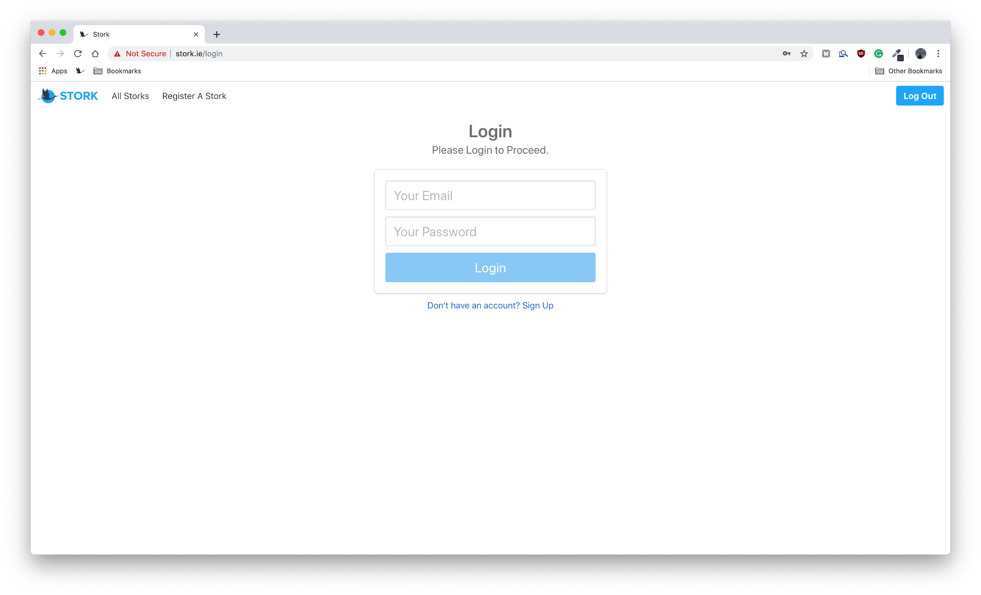

Figure 18: Stork “login” page

Moving onto the registration of a Stork device, the user story below describes a user successfully registering their Stork device (Figure 19).

## 

Figure 19: Valid stork registration user story

As a result of the user story format, two additional pages were created; Stork Device register and Stork Device tracking (Figures 20 and 21).

Stork **Device Register** Page - <http://stork.ie/storks/register-stork>

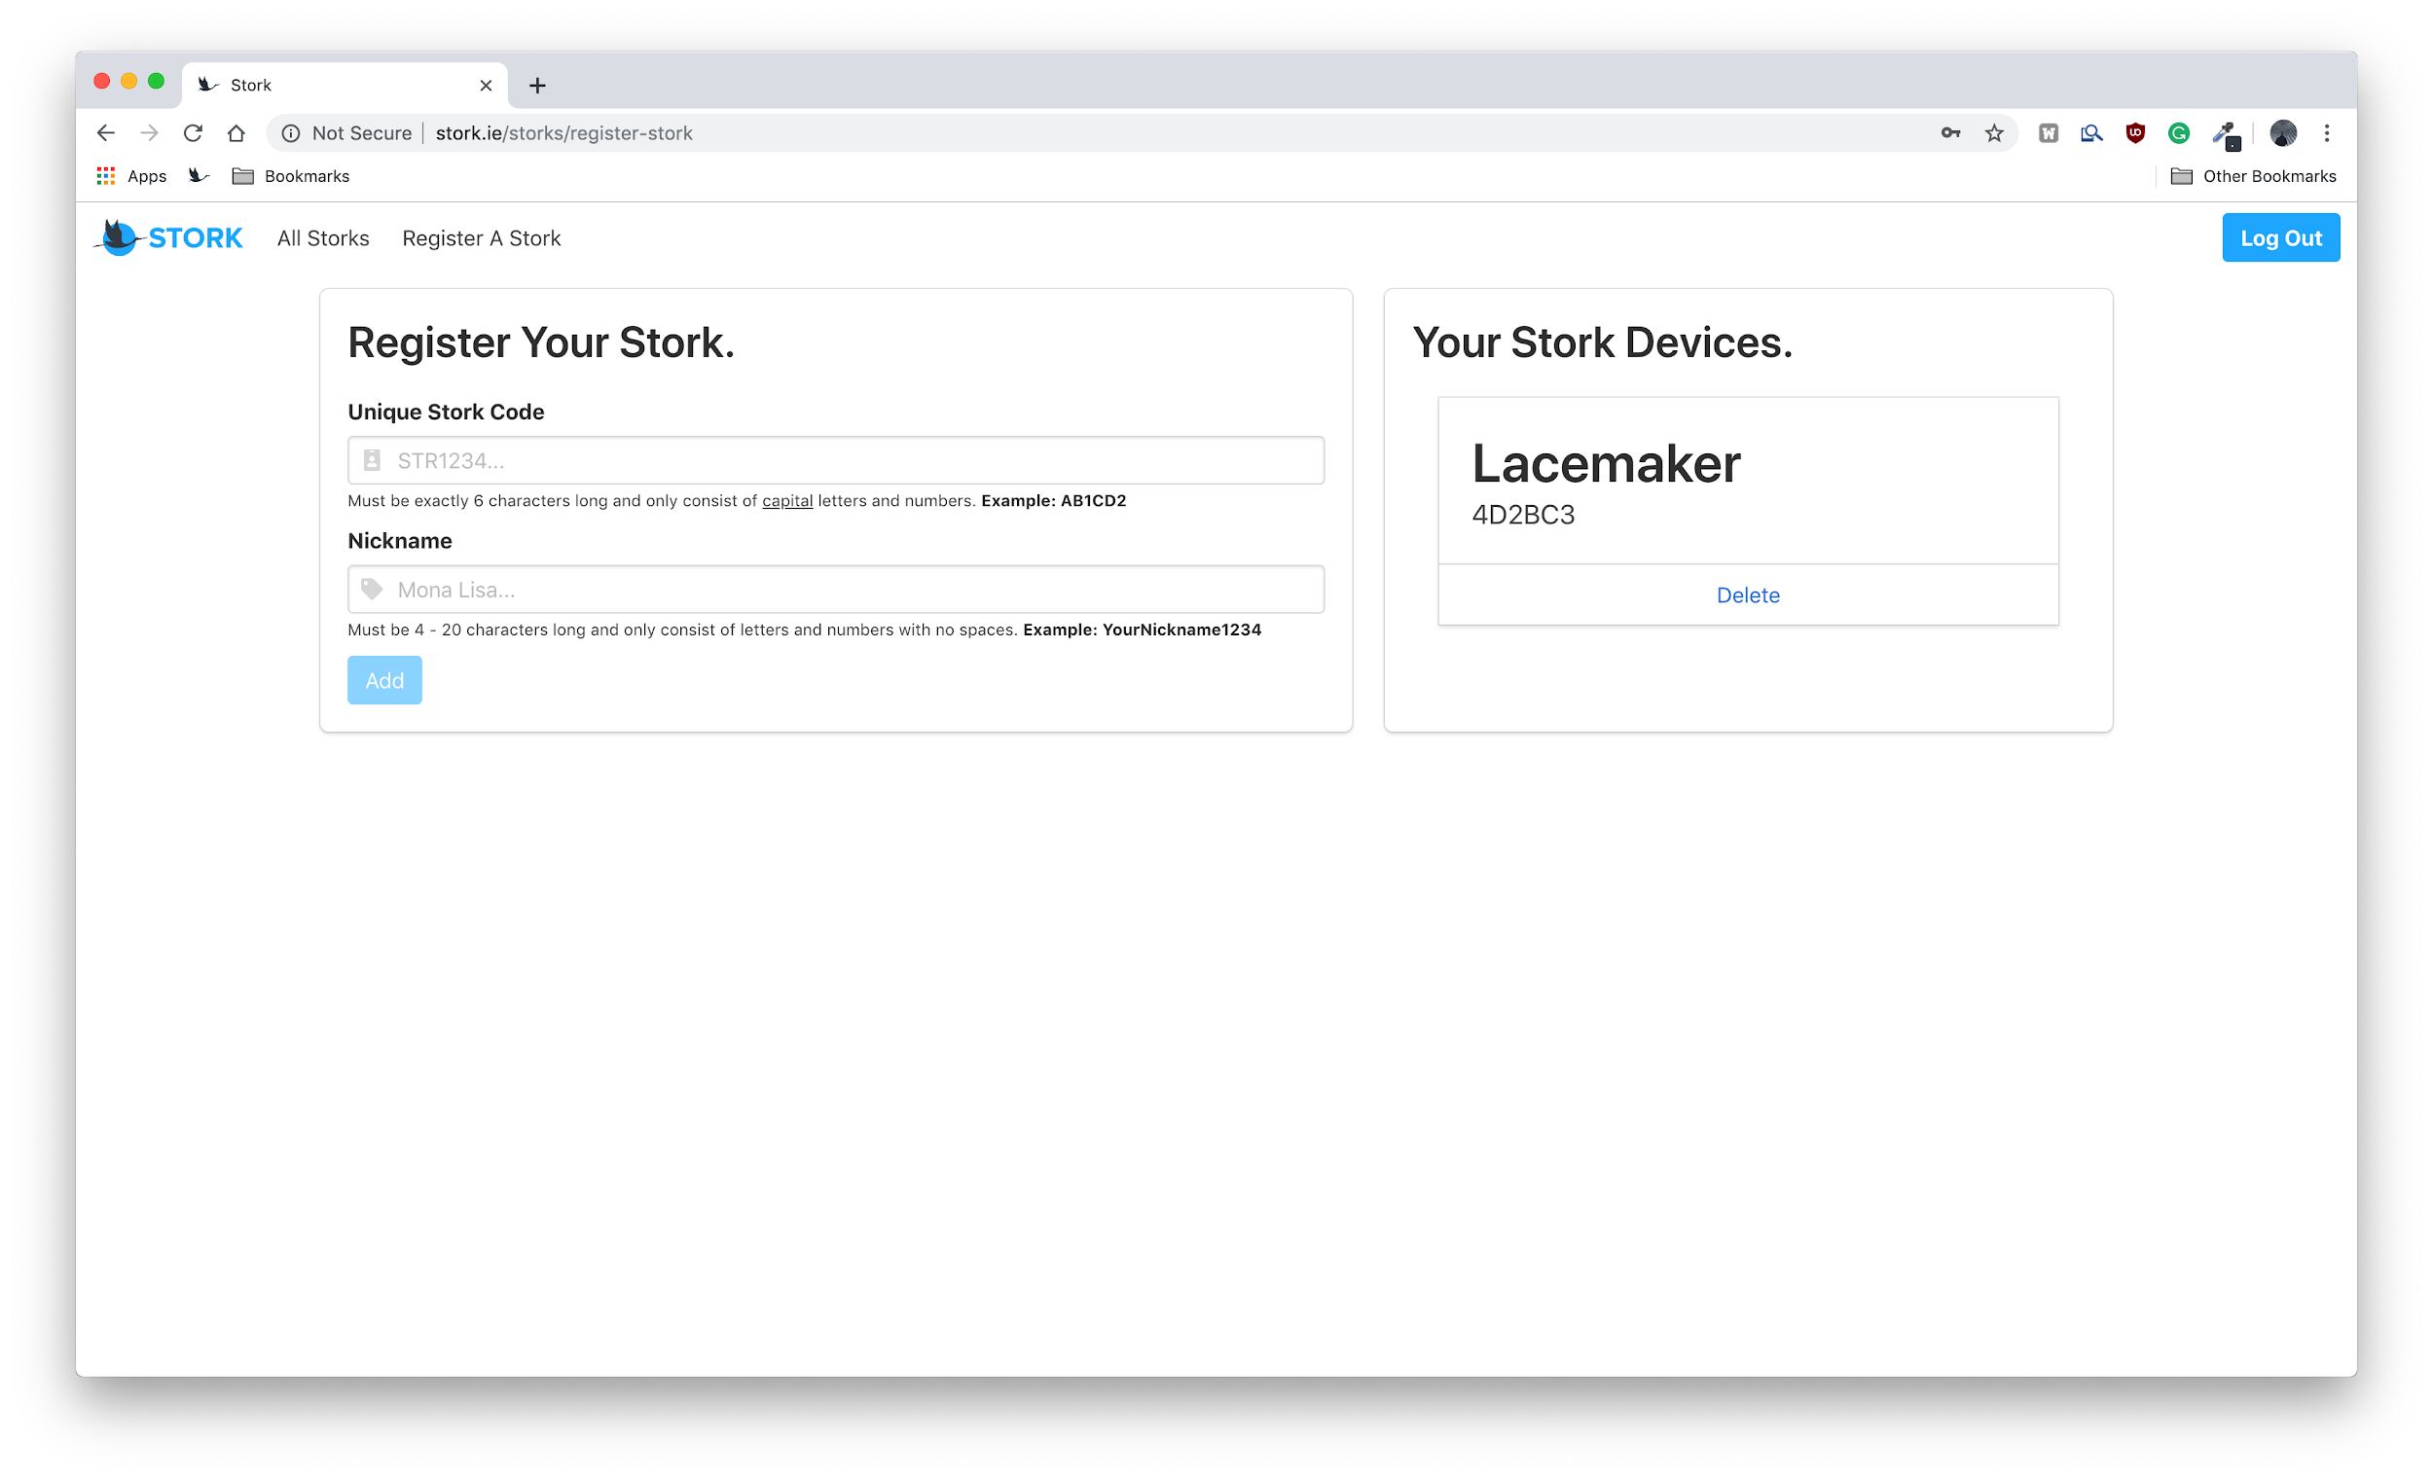

Figure 20: Stork Device register page

Stork **Device Tracking** Page - <http://stork.ie/storks/your-storks>

## 

Figure 21: Stork Device tracking page

As illustrated in Figures 16 and 19by using user stories to design the Stork user interface, a clean and easy to use web application has been developed.

### 

### 

### CSS Framework.

Stork was designed to be a modern product with a consistent color palette and style. In order to make Stork this, a modern and flexible css framework was chosen (Figure 22).

The CSS framework used for Stork was [bulma](http://bulma.io). Bulma is a free, open source CSS framework based on Flexbox. It has a flat and colorful selection of components to choose from which are easily customizable. Finally, the framework itself is extremely lightweight with only what is needed being imported.

Stork’s palette is based on three main colors: #299FFF, #353744, #FFFFFF and has been applied to Stork’s logo, web application, device instructional cards etc.



Figure 22: Stork color palette

In 2019, a significant number of people access the internet through a mobile phone or tablet so an important feature was to make sure the Stork Web Application is responsive regardless of the device being used. Since Bulma is based on FlexBox, this is possible (Figures 23 - 27).

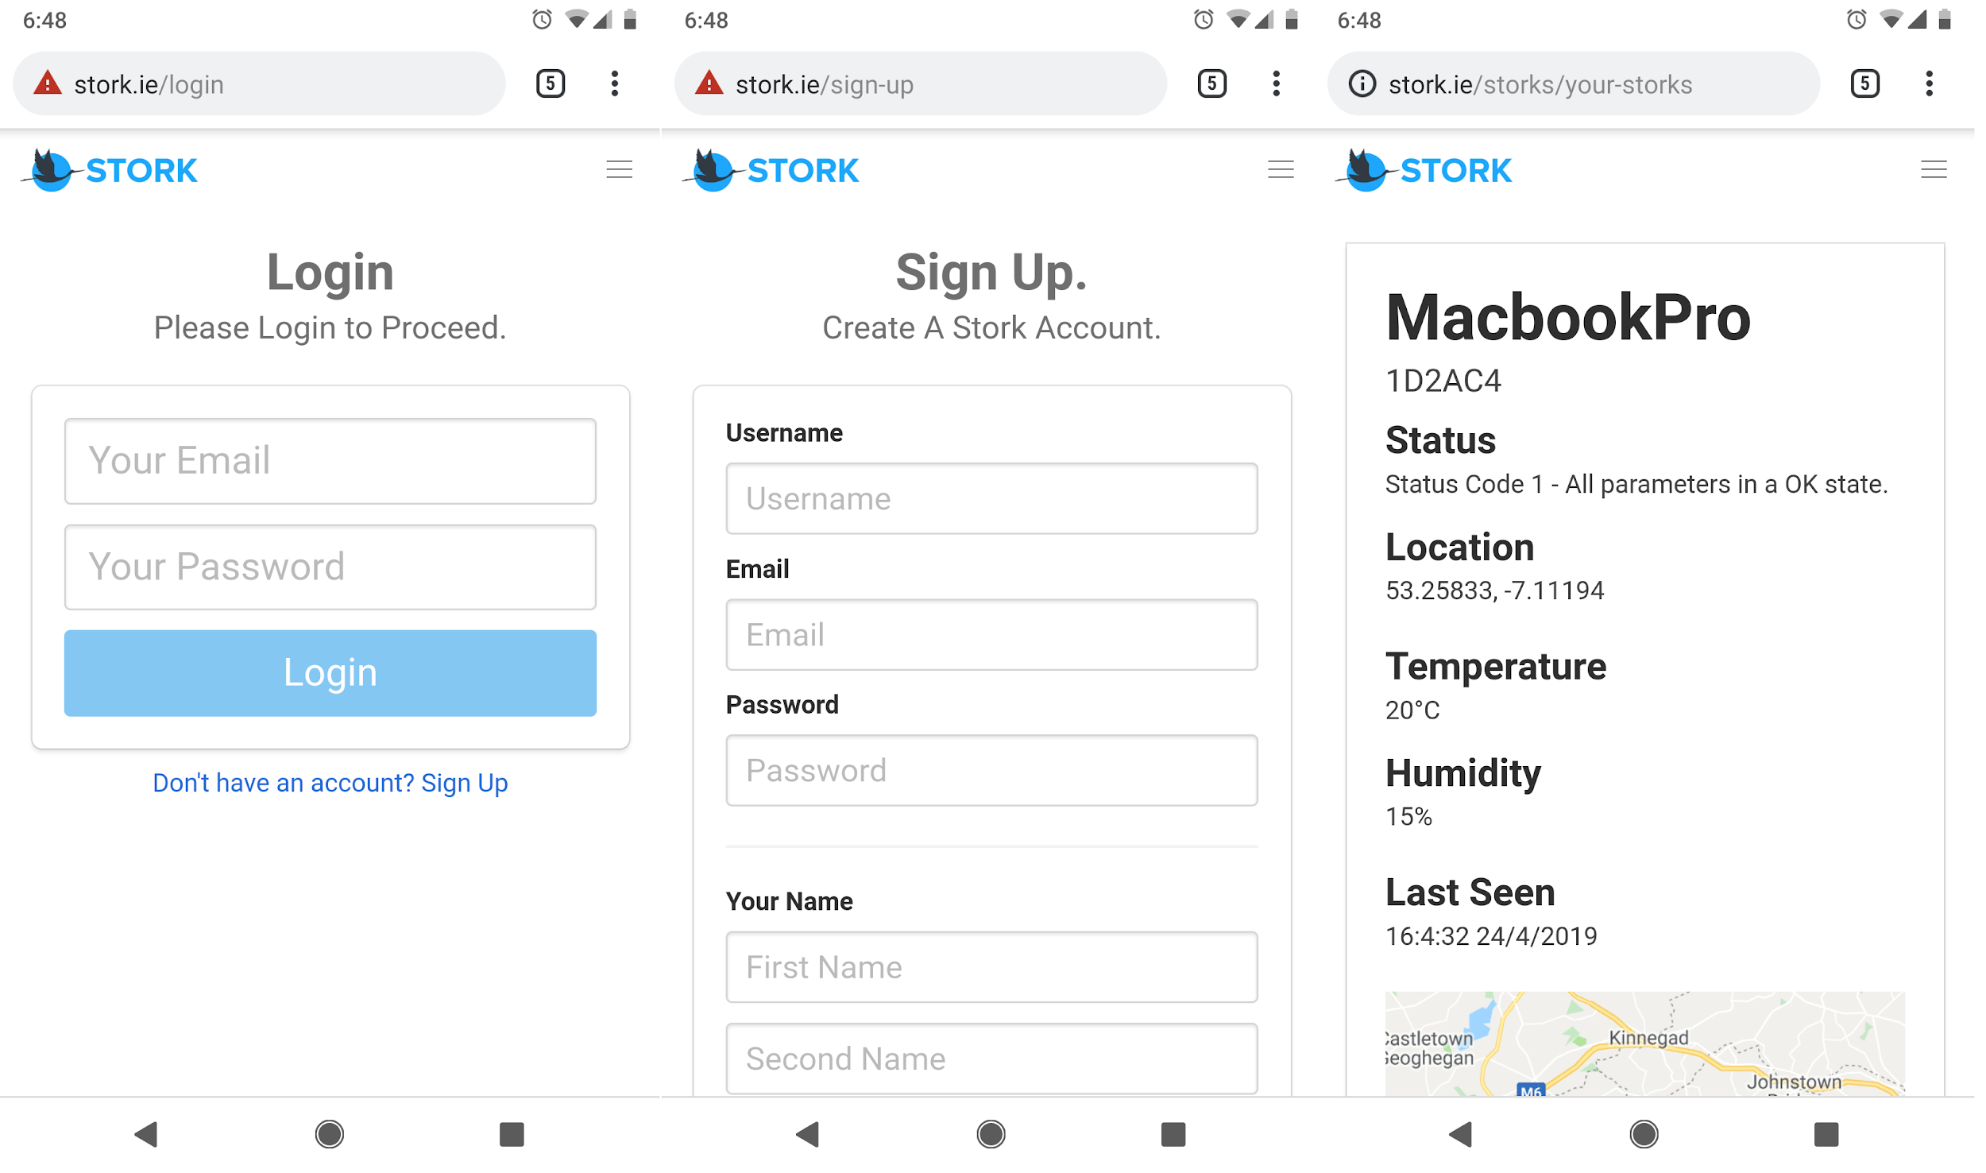

Figure 23: Stork web application on a mobile phone

When the Stork Web Application is viewed on a mobile device the navbar switches from its normal desktop appearance



Figure 24: Stork desktop navbar

To a menu which displays a hamburger menu

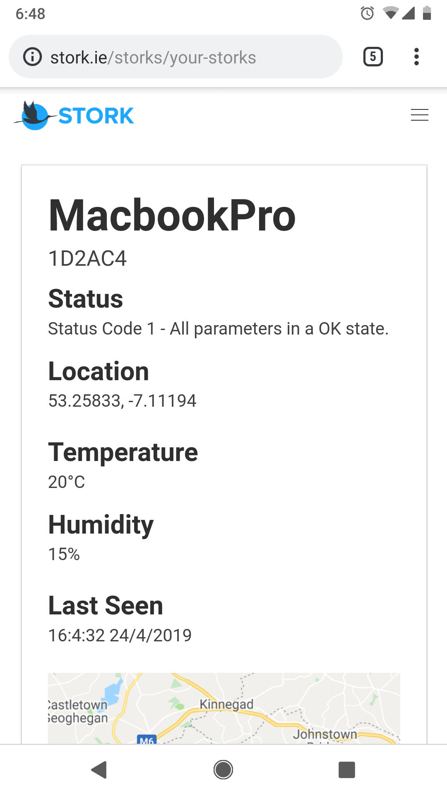

Figure 25: Stork mobile navbar

When the hamburger menu is tapped by the user, it transforms seamlessly to a cross and displays the navbar menu items

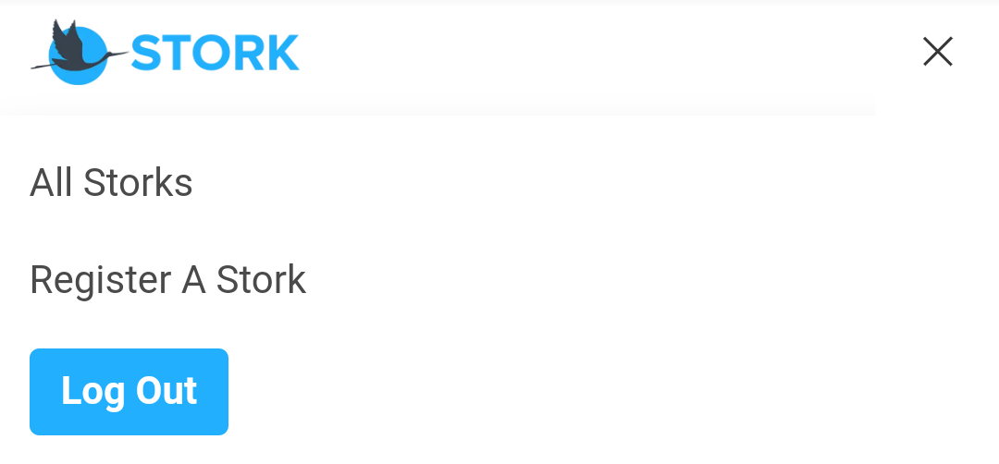

Figure 26: Stork desktop expanded navbar

When the user taps the cross again the menu closes:



Figure 27: Stork mobile navbar

### 

### Technologies Used.

The following section outlines the powerful, cutting edge technologies used to create the Stork frontend making the Stork an excellent web application.

#### Framework.

Stork is built with AngularJS 7, it uses a great deal of the framework’s feature set. This makes the Stork web application a modern, powerful and efficient application.

#### Components.

The entire Stork Web Application is built up from single components which are then inserted into pages where they are needed. This component-based application structure allows objects like the header to be re-used which improves app-wide efficiency (Figure 28).

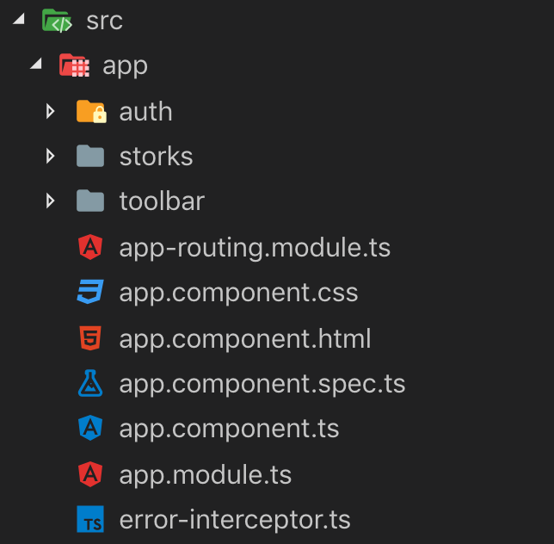

Figure 28: Stork component directory structure

There are three directories (auth, storks and toolbar) which contain components as well as the main component at the same level as these directories. How each of these component’s function is described below, in addition to where they are used.

app.component

The **toolbar** component (Figure 24), located in the *toolbar* directory, is first inserted in this component as the toolbar visibility is app wide.

| <app-header></app-header> |
| --- |

This is then followed by the router-outlet which acts as a placeholder that Angular dynamically fills based on the current state of the Angular router state.

| <router-outlet></router-outlet> |
| --- |

stork-login.component

This component, located in the *auth* directory, holds the login form (Figure 18) which is displayed at the landing page of the Stork Web Application.

stork-sign-up.component

This component, located in the *auth* directory, holds the sign up form (Figure 17) which is displayed at the **/sign-up** route.

stork-create.component

This component, located in the *stork* directory, holds the Stork device registration form (Figure 20) which is displayed at the **/storks/register-stork** route.

stork-list.component

This component (Figure 29), located in the *stork* directory, holds the component which lists the current users Stork device(s) which is displayed at the **/storks/your-storks** route.

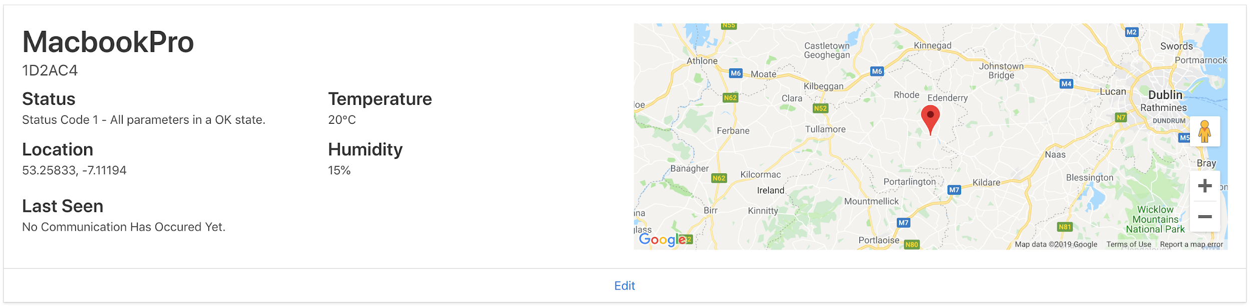

Figure 29: Stork device card; tracking version

This component (Figure 30) is also displayed alongside the component stork-create component.

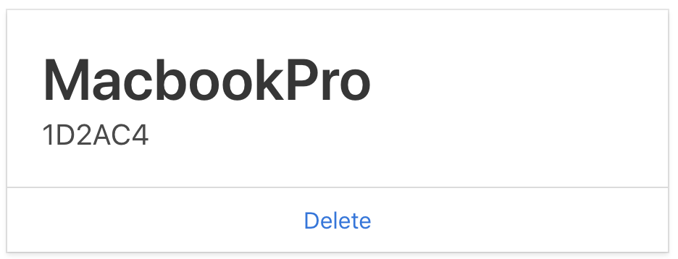

Figure 30: Stork device card; list version

#### Ngif, Else & Ng Template.

At first glance you would think they are two separate components but they are not. I wanted to allow the user to view their current Stork devices as they added another one.

For this I used Angular’s structural directive **ngif,** that conditionally includes a piece of html based on the value of an expression. An example of this would be the footer Stork:

| <footer class="card-footer">  <**a**  *ngIf="router.url === '/storks/your-storks'"  class="card-footer-item"  [routerLink]="['/storks/edit', stork.id]"  >Edit</**a**>  <**a**\*ngIf="router.url.includes('/storks/edit/') || router.url === '/storks/register-stork'"  class="card-footer-item"  (click)="onDelete(stork.id)"  >Delete</**a**> </**footer**> |
| --- |

The above functions in the following way:

* If the user is on the **/storks/your-storks** route display the edit button
* If the user is on the **/storks/register-stork** and the router url contains **/storks/edit/** (which means the user is editing a Stork device) display the delete button.
* The above two conditions cannot all be true at the same time so the user only sees the edit and delete button when they should.

The tracking version (see figure 29)of the Stork card hides nothing while the list version (see figure 30) of the Stork card uses the same idea of hiding and displaying html based on the current router url.

A great example of the use to ng-template is on the “/storks/your-storks” route:

| <div *ngIf="storks.length; else noRegisteredStorks"> |
| --- |

The ngIf checks if the storks.length (the number of current Storks for the current user).

If it is greater than zero the users Storks are displayed (see figure 31)**.**

| <div *ngIf="storks.length; else noRegisteredStorks">  <div class="card" *ngFor="let stork of storks">  <div class="card-content">  <div class="columns">  <div class="column">  <div class="media">  <div class="media-content">  <p *ngIf="stork.nickname; else noNickname" class="title is-2">  {{ stork.nickname }}  </p>  ... |
| --- |

If there are no registered Stork devices, then the **noRegisteredStorks** template is displayed.

| <ng-template #noRegisteredStorks>  <div *ngIf="router.url === '/storks/your-storks'">  <section class="section">  <div class="container">  <div class="columns is-centered">  ...  </div>  </div>  </section>  </div> </ng-template> |
| --- |

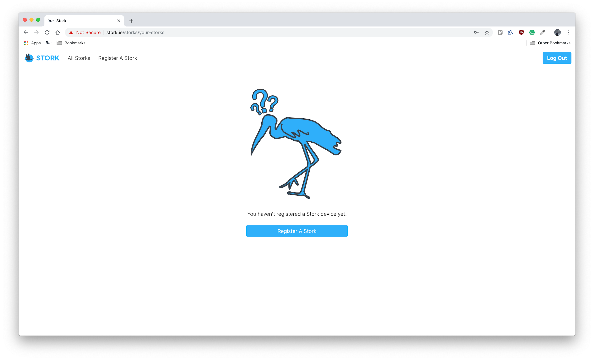

Figure 31: Stork device list when a user has no devices

#### 

#### Modules.

To avoid having a large app.module file which manages all the Angular imports needed, Angular’s ability to bring together smaller, individual module files was used to great effect. This improves developer experience as well as the overall performance of the web application.

An **auth.module.ts** was created to handle the declarations and imports relating to the login and signup pages.

A **storks.module.ts** was created to handle the declarations and imports relating to the main dashboard for the registration and tracking of a Stork device.

Lazy Loading.

Using Angular’s power router, the only modules loaded were ones which were required when the user first visits the site. In doing so, the user’s browser does not need to load all the pages on the web application. This has the obvious benefit of speed given the fact that not all users who visit the Stork application will sign up for an account or log in.

When the user does log in, the Stork application is then commanded to load the rest of the modules in the **app-routing.module.ts** file:

| {  path: 'storks',  loadChildren: './storks/storks.module#StorksModule' } |
| --- |

This technique of loading is mostly effective for huge applications such as Amazon or GitHub but adding this to the Stork Web Application makes it the application scalable. This will enable it to handle pages that could be added to it in the future if development were to continue.

#### 

#### Auth Guards.

Stork features a number of route guards which are interfaces which were configured to tell the router whether or not it should allow navigation to a route requested by a user.

| export class AuthGuard implements CanActivate {  constructor(private authService: AuthService, private router: Router) {}  canActivate(  route: ActivatedRouteSnapshot,  state: RouterStateSnapshot  ): boolean | Observable<boolean> | Promise<boolean> {  const isAuth = this.authService.getIsAuth();  if (!isAuth) {  this.router.navigate(['/login']);  }  return isAuth;  } } |
| --- |

The router then make this decision by looking for a true or false return value (isAuth in the above code snippet) from a the **AuthGuard** class which implements the guard interface created.

In order to demonstrate how the Auth Guards works, an attempt to edit a Stork from an Chrome incognito window will be made where a user is not signed in as follows:

As the user **luke123halley**, I can edit my Stork with the id of 5cc07af9472a090015832244 (Figure 32).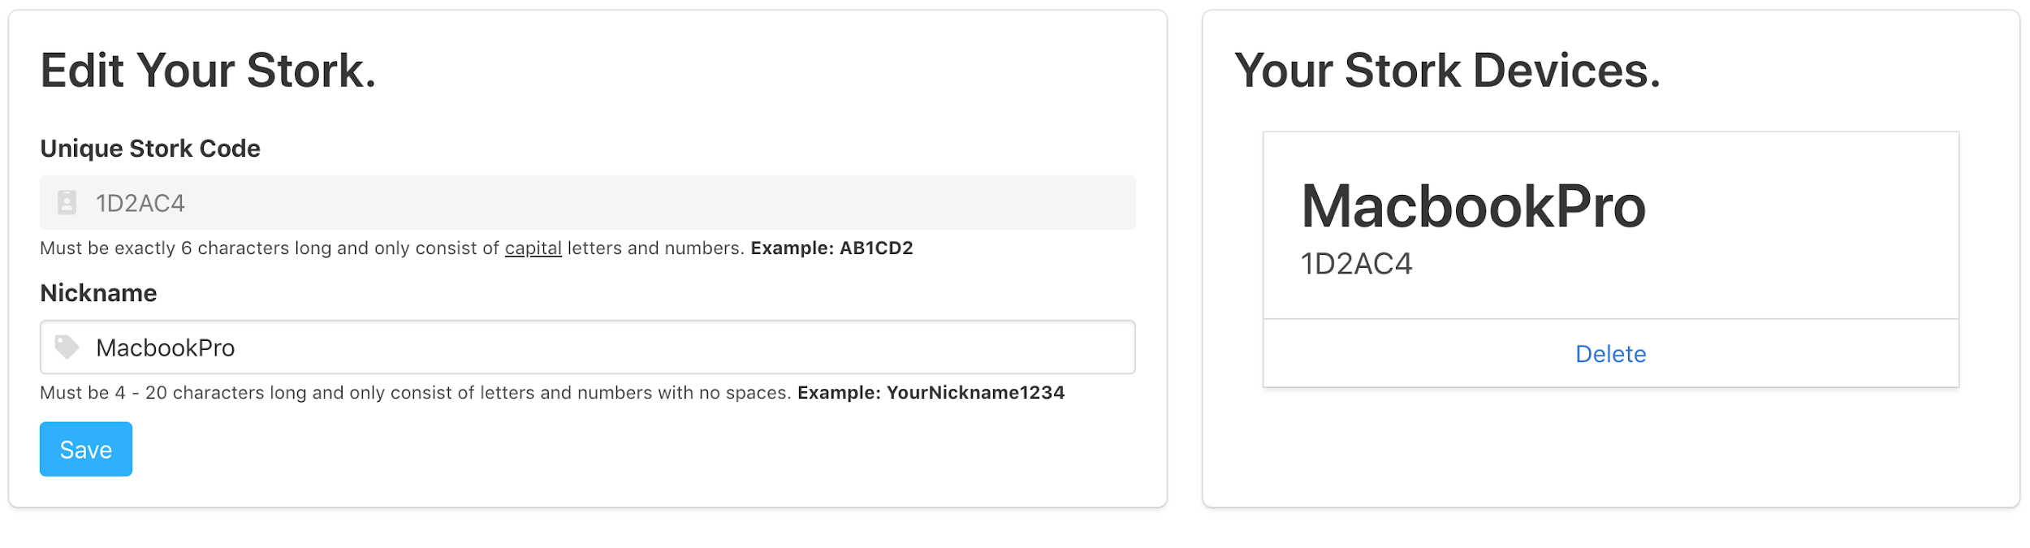

Figure 32: Editing the Stork device “1d2ac4” as the owner

Editing of this Stork device occurs at the following route:

[storks/edit/5cc07af9472a090015832244](http://stork.ie/storks/edit/5cc07af9472a090015832244)

Now if the **HugoCortot** user logged in (Figure 33).

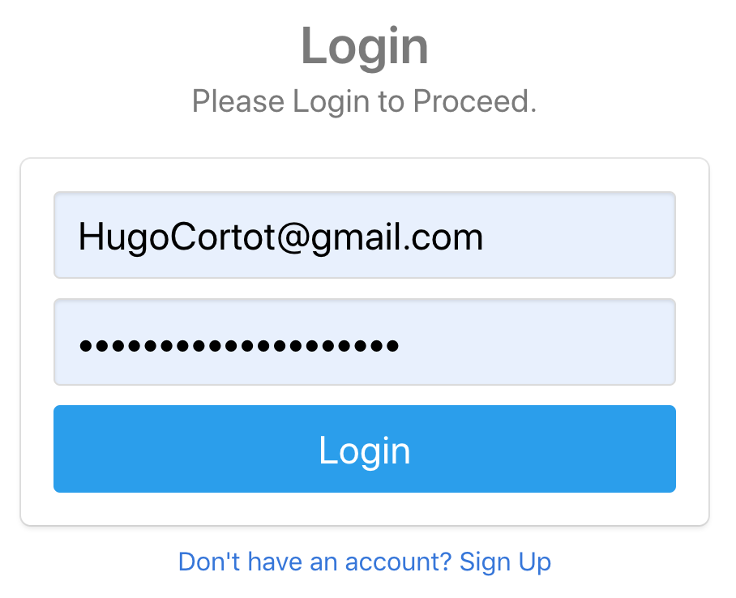

Figure 33: Logging in as HugoCortot

and went to the edit url for **luke123halley’s** device (Figure 34).

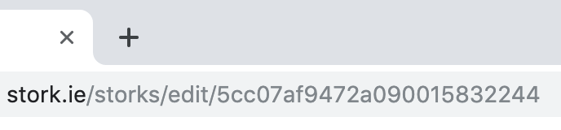

Figure 34: Visiting the edit url for luke123halley’s device

If the **HugoCortot** tries to change **luke123halley’s** device nickname to *ANewName* (Figure 35).

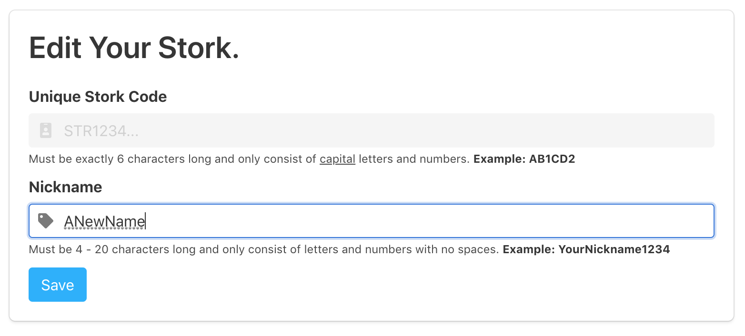

Figure 35: Trying to edit the Stork device “1D2AC4”

As expected the **AuthGuard** stops **HugoCortot** from doing this and displays and error (Figure 36).

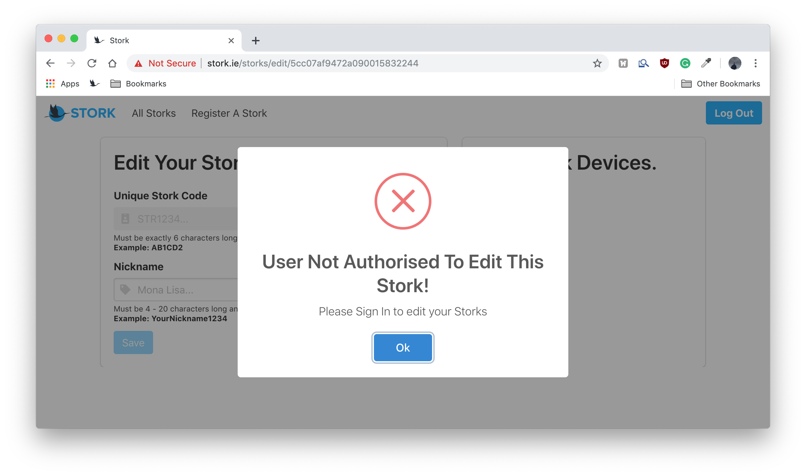

Figure 36: Unauthorised edit of the Stork device “1D2AC4” as the user “HugoCortot”

#### 

#### Form Validation.

All forms which are filled out by a user are validated in real time using Angular form validation. This Improves the overall data quality which is added to the Stork system by validating user input for accuracy and completeness.

Take for example, if a user attempts to enter an invalid email when signing up (Figure 37).

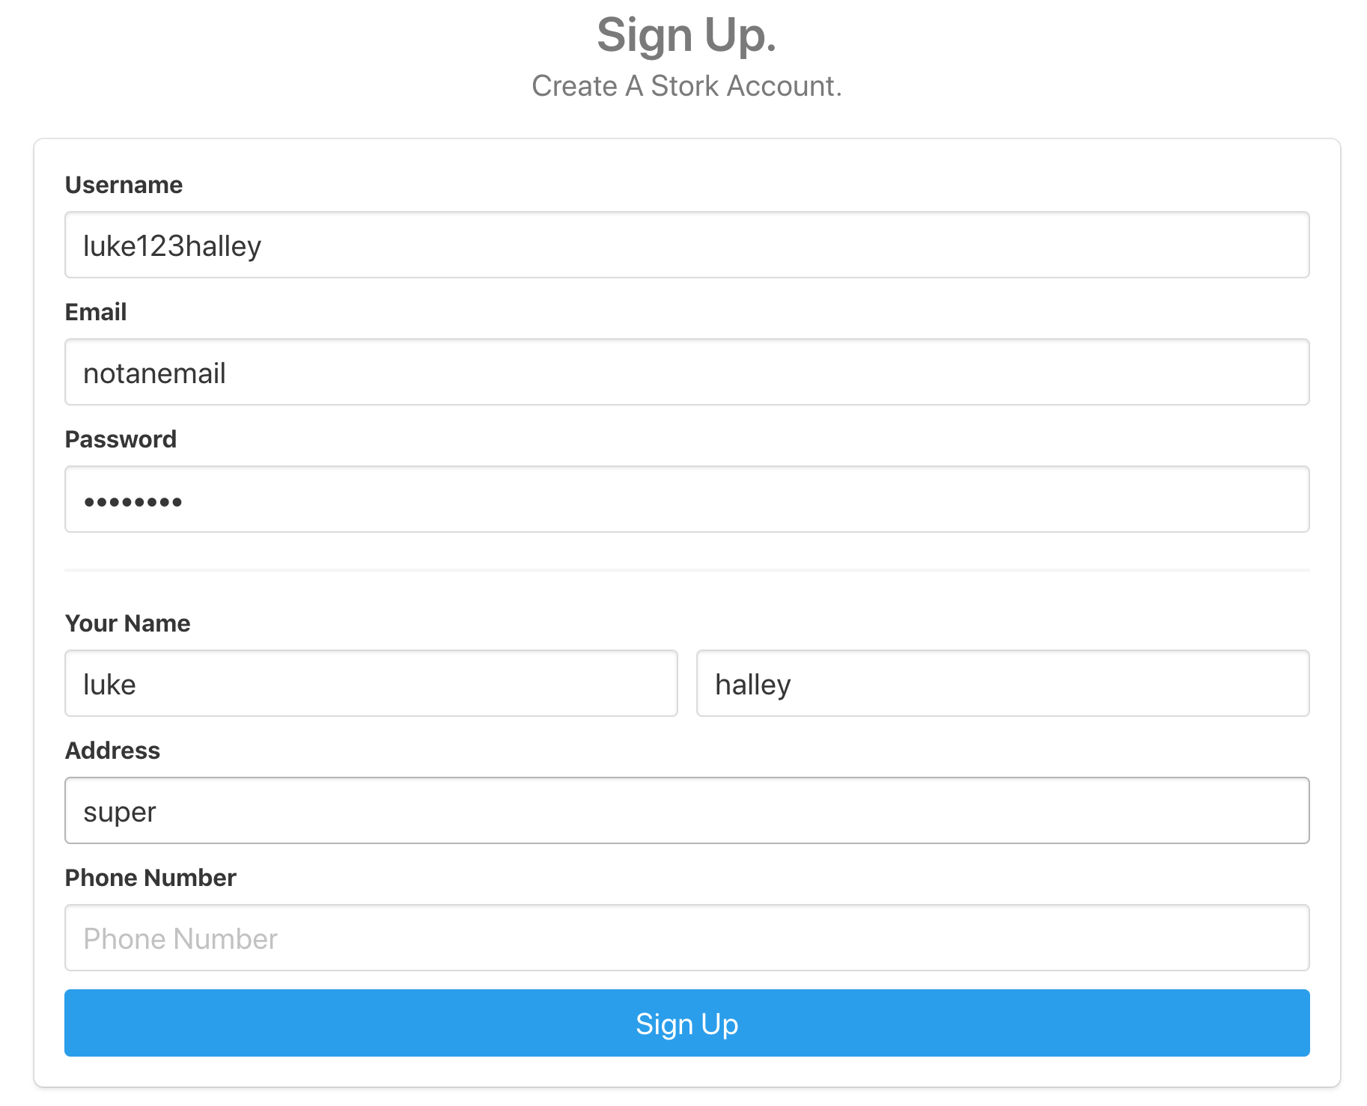

Figure 37: Invalid sign up parameters

An error will be displayed to the user in a pop up (Figure 38).

#### 

Figure 38: Popup triggered via form validation

This is done by declaring the type in the html, after that the Angular NgForm parses a users input and marks the form valid or invalid.

| <input  class="input is-medium"  ngModel  type="email"  placeholder="Email"  name="inputUserLoginEmail"  required /> |
| --- |

That valid boolean it then used to allow or not allow the user to proceed. In the code snippet below for example, a user is only created if the form is valid.

| onSignUp(form: NgForm) {  if (form.invalid) {  return;  } else {  this.authService.createUser(  form.value.inputUserSignUpFName,  form.value.inputUserSignUpSName,  form.value.inputUserSignUpAddress,  form.value.inputUserSignUpPhoneNumber,  form.value.inputUserSignUpUsername,  form.value.inputUserLoginEmail,  form.value.inputUserLoginPassword,  'free'  );  } } |
| --- |

#### 

#### Environment Variables.

Two files located in the **environments** folder which are environment.prod.ts and environment.ts.

**environment.prod.ts**

These are the parameters when the Stork Angular app is being run in production mode.

| **export const environment = {  production: true,  baseUrl: 'http://87.44.18.111',  apiUrl: 'http://87.44.18.111' + ':3000/api' };** |
| --- |

**environment.ts**

These are the parameters when the Stork Angular app is being run for local development.

| **export const environment = {  production: false,  baseUrl: 'http://localhost',  apiUrl: 'http://localhost' + ':3000/api' };** |
| --- |

These environment variables are then used in files such as **storks.service.ts**.

They are imported

| import { environment } from 'src/environments/environment.prod'; |
| --- |

URLs are constructed in the file

| const BACKEND_URL_STORKS = environment.apiUrl + '/storks'; const BACKEND_URL_DEVICES = environment.apiUrl + '/devices'; |
| --- |

And finally use them

| .get<{ message: string; storks: any }>(BACKEND_URL_STORKS + '/' + userId) |
| --- |

Using environment variables makes the whole system modular. If in the future, the backend of Stork was moved to another host, all that would have to be done is to change the relevant parameters in the **environment.prod.ts** file and everything would work perfectly again. Again, greatly improving developer experience.

#### RXJS.

RXJS is a [package](https://www.npmjs.com/package/rxjs) which facilitates reactive programming using observables allowing asynchronous code to be composed throughout the Stork frontend. Observables were heavily used in Stork, the RXJS library provided utility functions for creating and working with these observables. The library was mainly used for:

* Iterating through values in the data streams of the frontend;
* Mapping values to different types (users, storks);
* Filtering streams of data within Stork.

For example in my storks.service file a list of Storks was created with an rxjs **Subject**

| **private storksUpdated = new Subject<Stork[]>();** |
| --- |

and when a Stork device is registered a copy of it is pushed to this list

| this.storksUpdated.next([...this.storks]); |
| --- |

when this Stork is pushed to the list the whole application is notified and is updated.

Another function which was heavily used in the frontend of Stork was RXJS’s subscription service. This was used to subscribe observables to one another so when any changes occured in my application another part of the system was updated instantly.

Subscriptions are used to monitor if a user is logged in/authenticated

| private authStatusSub: Subscription; |
| --- |

This subscription is then used in various places, for example when getting a user’s Stork device.

| this.authStatusSub = this.authService  .getAuthStatusListener()  .subscribe(isAuthenticated => {  this.userIsAuthenticated = isAuthenticated;  this.userId = this.authService.getUserId();  if (isAuthenticated) {  this.storksService.getStorks(this.userId);  this.agmMap.triggerResize();  } else {  }  }); |
| --- |

When the user logs out, the subscription to the users authorisation status is then unsubscribed to

| ngOnDestroy(): void {  this.storksSub.unsubscribe();  this.authStatusSub.unsubscribe(); } |
| --- |

#### Sweetalert2 & HttpInterceptor.

HttpInterceptor allows the Stork application to intercept an error and return it as a value. Sweetalert2 is a sleek replacement for standard javascript popups which facilitates a display of popups to the user programmatically.

The Angular HttpInterceptor was paired with Sweetalert2 in order to build a custom, app-wide error interceptor (See figure 38 for an example of a Stork pop up)

This is added at the root **app.module**

| { provide: HTTP_INTERCEPTORS, useClass: ErrorInterceptor, multi: true } |
| --- |

This detects any http error responses and passes it to a Sweetalert2 popup

| export class ErrorInterceptor implements HttpInterceptor {  intercept(req: HttpRequest<any>, next: HttpHandler) {  return next.handle(req).pipe(  catchError((error: HttpErrorResponse) => {  let errorMessage = 'An Unknown Error Occured!';  let errorComment = 'Please contact support!';  if (error.error.message) {  // If the error response has a message set it.  errorMessage = error.error.message;  }  if (error.error.comment) {  // If the error response has a message set it.  errorComment = error.error.comment;  }  Swal.fire({  title: errorMessage,  text: errorComment,  type: 'error',  confirmButtonText: 'Ok'  });  return throwError(error);  })  );  } } |
| --- |

#### 

#### Typescript.

As part of developing Stork, I chose to learn and use the Typescript language. Having never used it before, I found it a rewarding challenge understanding its application compared to that of Javascript.

One key bonus provided by Typescript was that it provided faster and more precise auto-suggestions when using the [TSLink](https://marketplace.visualstudio.com/items?itemName=ms-vscode.vscode-typescript-tslint-plugin) Visual Studio Code package. From previous development experience with Javascript, I found that I would run into bugs after running the code which meant I would then have to go back and fix it. In contrast, when using Typescript I knew instantly if I was doing something incorrectly.

The fact that Typescript is strongly typed also appeals to me, having used other languages like Kotlin which are also strongly typed. This, in my opinion made my code more clean and concise.

Finally I used Typescript for my frontend as it is specifically built only for client side code.

## 

## Backend.

### Technologies Used.

This section serves to outline some of the powerful, cutting edge technologies used to create the Stork backend making the Stork an excellent web application.

#### Bcrypt.

Bcrypt is a key **security** feature of the Stork frontend which allows me to hash the users password before storing it in the Stork database.

| bcrypt.hash(req.body.password, 10).then(hashedPassword => {  const user = new User({  fname: req.body.fname,  sname: req.body.sname,  address: req.body.address,  phoneNumber: req.body.phoneNumber,  username: req.body.username,  email: req.body.email,  password: hashedPassword,  plan: req.body.plan  }); |
| --- |

The hash is created using the users pass and email which means the password can only be seen by the server when given the correct credentials. The hashing of Storks users passwords removes the risk of storing passwords in plain text which in theory, could be used for malicious activity.

#### JSON Web Tokens.

This is implemented using [**jsonwebtoken**](https://www.npmjs.com/package/jsonwebtoken)npm package**.**

Upon a successful login, a user has a JSON web token generated for them by the server which is then stored in their browsers local storage. This token is a long, hashed string which is created by using the user’s credentials.

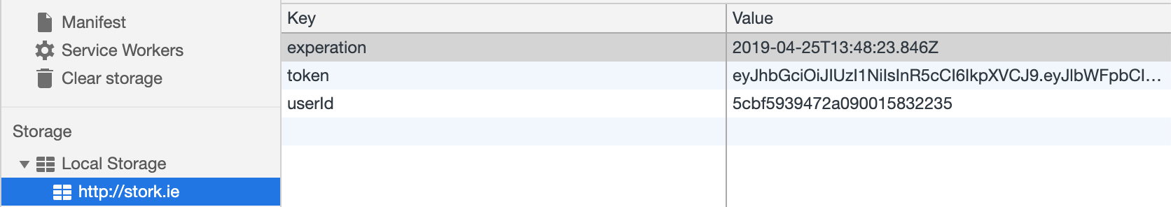

Figure 39: Json web token in local storage

This token is then attached to all requests made by the user to the Stork server as a header. The main advantage of using tokens like this is it is impossible to fake as it is hashed in a way which prevents this, any changes to the token will invalidate it and leave it unusable. Only the Stork server can validate it as it has created it.

#### Mongoose.

Mongoose was used to manage the relationships between Stork data within my MongodDB.

Mongoose was used to create schemas for Users; Schema for Stork user accounts

| const userSchema = mongoose.Schema({  fname: { type: String, required: true, unique: false },  sname: { type: String, required: true, unique: false },  address: { type: String, required: true },  phoneNumber: { type: String, required: false },  username: { type: String, required: true, unique: true },  email: { type: String, required: true, unique: true },  password: { type: String, required: true },  plan: { type: String, default: 'free' } }); |
| --- |

Mongoose allowed a field to be declared as a required. This ensured all parameters that were needed to create a valid user were received from the frontend.

I was able to declare if a field must be unique using the [mongoose-unique-validator](https://www.npmjs.com/package/mongoose-unique-validator) package which was an efficient way for me to only allow a user sign up with an email once.

| const uniqueValidator = require('mongoose-unique-validator'); deviceSchema.plugin(uniqueValidator); |
| --- |

Stork Devices; Schema for registerable Stork devices.

| const deviceSchema = mongoose.Schema({  dev_code: { type: String, required: true, unique: true },  available: { type: String, required: true },  ownerId: { type: String, required: false } }); |
| --- |

Stork; Stork devices which are registered on the Stork Web Application.

| const storkSchema = mongoose.Schema({  stork_code: { type: String, required: true, unique: true },  lastSeen: { type: String, default: 'No Communication Has Occured Yet.' },  nickname: { type: String, required: true },  ownerId: {  type: mongoose.Schema.Types.ObjectId,  ref: 'User',  required: true  },  location: {  type: pointSchema,  required: true  },  statusCode: { type: Number, required: true },  statusMessage: { type: String, default: 'Device Status Unknown.' },  temperature: { type: Number },  humidity: { type: Number } }); |
| --- |

For the above schema I created “sub schema” to hold the location of the device. The following schema is based on the specification of MongoDB’s support of query operations on [geospatial data](https://docs.mongodb.com/manual/geospatial-queries/).

| const pointSchema = new mongoose.Schema({  type: {  type: String,  enum: ['Point'],  required: true  },  coordinates: {  type: [Number],  required: true  } }); |
| --- |

#### 

#### Environment Variables.

The environment variables in the backend are quite similar to the ones in the front end except they are stored in a file called **.env**

| PORT=3000 MONGO_PW=vfk6er5NOoVTm... MONGO_DATABASE=stork-production JWY_KEY=AfwSq-jPWPN&9$nRn5QyEpRtkGaH#nNuhfmAyfKm%_8WV*_aFrgKupcAz... |
| --- |

This file is imported using the [dotenv](https://www.npmjs.com/package/dotenv) package.

| const dotenv = require('dotenv'); dotenv.config(); |
| --- |

These variables are then used in files such as **app.js**

| mongoose  .connect('mongodb://database:27017/' + process.env.MONGO_DATABASE)  .then(() => {  console.log('Connected to ' + process.env.MONGO_DATABASE + ' Database!');  })  .catch(e => {  console.log('Connection Failed Database! ' + e);  }); |
| --- |

#### 

#### ExpressJS.

Express was used to create all my api’s for the Stork backend. See page 44 for a **full** list of APIs used.

To ensure I kept my code I split my routes into three sections

* Devices: routes which handle all operations on registerable devices;
* Storks: routes which handle all operations on storks registered on the Stork web application;
* Users: routes with all operations for Stork users.

In my app.js file I then pointed the routes to their correct route folder.

| // Filter all routes going to /api/storks to use storkRoutes. app.use('/api/storks', storkRoutes);  // Filter all routes going to /api/users to use userRoutes. app.use('/api/users', userRoutes);  // Filter all routes going to /api/users to use deviceRoutes. app.use('/api/devices', deviceRoutes); |
| --- |

To ensure my API’s were **secure** I set the allowed headers.

| app.use((req, res, next) => {  res.setHeader('Access-Control-Allow-Origin', '*');  res.setHeader(  'Access-Control-Allow-Headers',  'Origin, X-Requested-With, Content-Type, Accept, Authorization'  );  res.setHeader(  'Access-Control-Allow-Methods',  'GET, POST, PATCH, PUT, DELETE, OPTIONS'  );  next(); }); |
| --- |

#### 

#### Middleware

Middleware was created for my backend to check if the user is allowed access a route using the previously mentioned JSON web tokens.

The middleware works by extracting the JWT from the header of a request,

| const token = req.headers.authorization.split(' ')[1]; |
| --- |

and use JWT to verify the token.

| const decodedToken = jwt.verify(token, process.env.JWY_KEY); |
| --- |

If the verify works, know its a valid token else it will fail and go into the catch block:

| req.userData = {  email: decodedToken.email,  userId: decodedToken.userId  };  next(); } catch (error) {  console.error(error);  res.status(401).json({ message: 'Your are not authorised, please Login!' }); } |
| --- |

## 

## APIs.

In the following section, the full collection of API’s used in the Stork system are as follows:

* **Stork Devices**: All API’s which are related to managing registerable Stork devices;
* **Registered Stork**: All API’s which are related to managing registered Stork devices;
* **Users**: All API’s which are related to managing Stork users.

### Stork Devices.

| **HTTP Method** | **Path** | **Description** |
| --- | --- | --- |
| GET | /admin/available-device/:dev_code | Get a single registerable device. |
| POST | /admin/available-device/add | Add a registerable device to allow a user to register the it. |
| PUT | /admin/available-device/update/:dev_code | Associate a user with a Stork device. |
| DELETE | /admin/available-device/add | Delete one registerable Stork device from the database. |

### Registered Stork.

| **HTTP Method** | **Path** | **Description** |
| --- | --- | --- |
| GET | /:ownerId | Get registered all Storks from the database for a user. |
| GET | /one/:id | Get registered one Stork from the database by its id. |
| POST | no path | Create a registered Stork and send it to the database to be stored. |
| PUT | /:id | Update a registered Stork. |
| PUT | /push/:stork_code | Push data from a Stork device. |
| DELETE | /:id | Delete a registered Stork from the database. |

### Users.

| **HTTP Method** | **Path** | **Description** |
| --- | --- | --- |
| POST | /signup | Create a Stork user account. |
| POST | /login | Login a User allow them to access their profile. |

## Database.

The following section outlines the database technology that the Stork system utilizes.

The Stork uses a [MongoDB database image](https://hub.docker.com/_/mongo) from Docker hub. MongoDB document databases provide high availability vital for Stork as customers wanting to track their packages at all times. (see page 62) for further details on how Docker was used to create and manage the Stork database.

### Collections.

A single database, **stork-production** was used with the three following collections.

#### Devices.

Collection with contains all Stork devices which are available for registration.

Example document:

| {   "_id":ObjectId("5cbf5cc5472a090015832239"),  "dev_code":"4D2BC3",  "available":"false",  "ownerId":"5cbf5939472a090015832235",  "__v":0 } |
| --- |

where:

* **_id**: field that acts as a primary key for each device. The MongoDB driver automatically generates this ObjectId.
* **dev_code**: The unique Stork code associated with the Stork device.
* **devices**: routes which handle all operations on registerable devices.
* **available**: Boolean which indicates if this device is available to be registered by a user. This field is by default true, but in this case it has been registered by a user which switched it to false.
* **ownerId**: The Stork user id of the user who registered this Stork to their account.
* **__v:** Version key property set on each document when first created by Mongoose.

The logic for having a seperate collection for the physical registerable Stork device was to ensure that the device collection was only being accessed via the Stork server and have no communication with the Stork web application.

#### Storks.

Collection which contains all Stork devices registered on the Stork web application by the user.

Example document

| {   "_id":ObjectId("5cc2cfa6472a090015832279"),  "lastSeen":"10:30:23 26/4/2019",  "statusMessage":"All parameters in a OK state.",  "stork_code":"4D2BC3",  "nickname":"Pixel2",  "ownerId":ObjectId("5cbf5939472a090015832235"),  "location":{   "coordinates":[   53.25833,  -7.11194  ],  "_id":ObjectId("5cc2cfa6472a09001583227a"),  "type":"Point"  },  "statusCode":1,  "temperature":20,  "humidity":15,  "__v":0 } |
| --- |

where:

* **_id**: field that acts as a primary key for each registered Stork. The MongoDB driver automatically generates this ObjectId;
* **lastSeen**: the last time at which the Stork device pushed data to the Stork API;
* **statusMessage:** The status message which has been translated in the Stork backend using the current status code;
* **stork_code**: the unique Stork code associated with the registered Stork;
* **nickname**: the nickname the owner of the Stork device has given to the registered Stork;
* **location**:
  + **coordinates:** the current latitude and the longitude (in that order) of the registered Stork device;
  + **_id**: field that acts as a primary key for each registered Stork. The MongoDB driver automatically generates this ObjectId;
  + **type:** specifies the GeoJSON object type, for the current of Stork all types are of type [Point](https://docs.mongodb.com/manual/reference/geojson/#point).
* **statusCode:** a number between 0 and 18 which is calculated on the Stork device. This number indicates the current state of the registered device. More on Stork codes can be found on page 55 or on the [Stork wiki](https://gitlab.com/stork-group/stork-web-service/wikis/Home#status-codes);
* **temperature**: the current temperature of the registered Stork’s environment;
* **humidity**: the current humidity of the registered Stork’s environment;
* **__v:** version key property set on each document when first created by Mongoose.

#### Users.

Collection which contains all Stork users who created a Stork user account.

Example document

| {   "_id":ObjectId("5cbc92c39d2d47000f369905"),  "plan":"free",  "fname":"Luke",  "sname":"Halley",  "address":"Carrolls Cross, Kilmacthomas, Waterford, Ireland",  "phoneNumber":"0831995649",  "username":"luke123halley",  "email":"luke123halley@gmail.com",  "password":"$2a$10$BlBeaCNOexRTEk7lZTTl9OuaXPpMRmk2CHOGuGpIDb9Bk56FFb.Au",  "__v":0 } |
| --- |

where:

* **_id**: field that acts as a primary key for each registered Stork. The MongoDB driver automatically generates this ObjectId;
* **plan**: the current price plan of the Stork user;
* **fname:** the first name of the Stork user;
* **sname**: the second name of the Stork user;
* **phoneNumber**: the phone number of the Stork user;
* **username:** the unique username of the Stork user;
* **username**: the unique email of the Stork user;
* **password**: the **hashed** password of the user. Stork users password are not stored in plain text;
* **__v:** version key property set on each document when first created by Mongoose.

## 

## Device.

In this section the code which is run on each Stork device will be outlined. The devices are programmed using MicroPython, a lean and efficient implementation of the Python 3 programming language. It includes only a small subset of the Python standard libraries which does add limitations but allows it to be optimised to run on microcontrollers and in constrained environments.

### Libraries Used.

A handful of libraries were used during the development of the Stork device:

* **Sigfox:** communicate with the Sigfox network;
* **Pytrack:** access the Pytrack’s accelerometer and GPS;
* **L76GNSS:** pytrack GPS driver;
* **LIS2HH12:** pytrack accelerometer driver;
* **socket:** used to set the socket for the Sigfox;
* **binascii:** used to print out the devices Stork code;
* **pycom:** used to set the LED color;
* **machine:** used for random number generation;
* **struct:** used for packing data into a byte array which is being sent to the Sigfox backend;
* **gc:** micropython garbage collector.

### Startup.

When the Stork device is first powered on, it starts by locking on to a GPS. The pytracks GPS must have a clear view of the sky in order to obtain a lock. During development, being inside a building caused a problem for testing. I found positioning beside a window worked **at times.** As a result, I was using generated latitude and longitude for the first iterations.

| fakeLat = 40.71427 fakeLong = -74.00597 |
| --- |

Of course, this would not be used in reality. At the start of the devices program I implemented the following **white** loop forces the program to wait for a GPS signal before moving on.

The device’s LED first goes orange while its locking onto a GPS signal. The pycom heartbeat must be set to False to set the LED color.

| pycom.heartbeat(False) pycom.rgbled(0xFF7000) time.sleep(2) print("Locking To GPS...") if waitForGPS and not fix:  while coord == (None, None):  coord = gps.coordinates() print("GPS Position Locked!") fix = True |
| --- |

After the GPS signal has been locked, the LED turns green. The **fix** boolean is then set to True which is used throughout the program to check that the GPS lock is still present.

Approximately five seconds later, the devices LED blinks blue, indicating that the device is now in its main monitoring loop.

### Monitoring Loop.

The Stork device monitors within an infinite loop. In this loop, there are a number of steps which the device goes through. In the following section the loop will be described through to the sending of data.

At the start if the loop, the current GPS coordinates is read and placed into two variables **lat** and **long.**

| **coord = gps.coordinates() lat, lng = coord** |
| --- |

After this, a timer is started. The device sends up data every ten minutes so this must be monitored.

The initial time is read during the setup before the loop.

| init_timer = time.time() |
| --- |

Then in the loop, the current time is read followed by a calculation which calculates the amount of seconds that has passed since the loop started.

| final_timer = time.time() timeElapsed = final_timer - init_timer |
| --- |

The first body of code the Stork device enters, detect mishandles. This runs for one minute at a time.

At first, two pitch values are collected and placed into a **rollValues** list and two roll values are collected and placed into the **rollValues** list.

| # Get two pitch values and two roll values while len(pitchValues) <= 1 and len(rollValues) <= 1:  # Add them to their respective  pitchValues.append(acc.pitch())  rollValues.append(acc.roll()) |
| --- |

After this, the difference between the two values in each list is calculated and then added.

| # After getting two pitch values and two roll values else:  # Get the difference between the sum of the two pitch values and the sum of the two roll  # values  difference = abs(pitchValues[1] - pitchValues[0]) + abs(rollValues[1] - rollValues[0]) |
| --- |

An example of this calculation would be:

Pitch Reading 1 = 0.5343, Pitch Reading 2 = 0.2543

Roll Reading 1 = 0.9456, Roll Reading 2 = 0.2034

Difference = (0.5343 - 0.2543) + (0.9456 - 0.2034)

Difference = 0.3222

The difference is then checked to decide if a mishandle has occured.

| # Detect a 002 mishandle (mishandles of medium severity) if difference > okLimit and difference < dangerLimit:  # Increment the count of the 002 mishandles detected  warnCount += 1 # Detect a 003 mishandle (mishandles of high severity) elif difference > warningLimit:  # Increment the count of the 002 mishandles detected  dangerCount += 1 else:  pass |
| --- |

There are three outcomes from the above based on the following parameters.

| okLimit = 30 warningLimit = 55 dangerLimit = 100 |
| --- |

- If the difference is over 55 it is counted at as “**dangerous**” mishandle;

- If the difference is less 55 and greater than 30 it is counted at as “**warning**” mishandle;

- If the difference is less than 30 there a mishandle didn’t occur.

These parameters were created through trial and error and could be edited to increase accuracy.

After sixty seconds, the current state of the device is checked on. To keep the counting of minutes simple, another **variable** is createdwhich tracks how many minutes has passed. The timer is then reset. Finally the **warning** count and **danger** count is printed out, more on these variables later.

| if (timeElapsed >= 60) and (minInt < sendCycle):  # Reset the timer  init_timer = time.time()  # Increment the minute counter  minInt += 1  print("{} Minutes Has Passed!".format(minInt))  print(  "Mishandle Counts - Warning Count: {} Danger Count: {} ".format(  warnCount, dangerCount  )  ) |
| --- |

If the above conditions are not met, it is then checked if ten minutes has passed. A large amount of code is in this statement, so the section will be broken up into small sections.

The number of **warning** counts and **danger** counts is then printed out. As well as this, the number of minutes which has passed is also printed out.

| print("{} Minutes Has Passed!".format(**minInt**)) print(  "Mishandle Counts - Warning Count: {} Danger Count: {} ".format(  **warnCount**, dangerCount  ) ) |
| --- |

If one or more dangerous mishandles has been detected or more than 5 warning (mishandles of medium severity) mishandles, the boolean **mishandle** is set to true. This boolean is used to report that the device is being mishandled.

| if (dangerCount > 0) or (warnCount >= 5):  # Set that there was a mishandle  mishandle = True  print(  "Mishandle Limit Exceeded - Sending Mishandle As {}!".format(mishandle)  ) else:  # Set that was not a mishandle  mishandle = False  print(  "Mishandle Limit Not Exceeded - Sending Mishandle As {}!".format(  mishandle  )  ) |
| --- |

Here is where the data is sent to the Sigfox backend. The GPS fix is first checked, then two random numbers are generated using the machine library to act as place holders for the temperature and humidity values. Finally, the **postData** function is called which is declared at the top of the Python file.

| if not lat is None and not lng is None: # Have a GPS fix  print("GPS Lock Acquired! - Sending Real GPS Data!")  if post:  pycom.heartbeat(False)  print("Posting REAL data!")  temp = int(str(machine.rng())[:2])  hum = int(str(machine.rng())[:2])  postData(lat, lng, temp, hum) |
| --- |

If the GPS signal is lost before the data is sent to the cloud, the device again enters a **while** loop which forces the program to wait for a GPS signal before moving on.

| else: # No GPS fix  print("GPS signal lost or could not be locked - Re-locking GPS signal!")  pycom.heartbeat(False)  # Set LED to RED  pycom.rgbled(0x7F0000)  if waitForGPS and not fix:  while coord == (None, None):  print("Waiting for GPS...")  coord = gps.coordinates()  print(coord)  print("GPS position regained!")  pycom.rgbled(0x00FFFF)  pycom.heartbeat(True)  fix = True |
| --- |

As mentioned previously, when ten minutes elapse, the data is sent by calling the **postData** function. In the first section of this function a total of eighteen conditional statements are used to decide which status code to send to the cloud.

The stork code is decided based on the following:

* **fix:** if the device has a current GPS lock;
* **hum:** the current humidity reading;
* **temp:** the current temperature reading;
* **mishandle:** if the device has been mishandled during the 10 minute interval;
* **sendfail:** if amount of times the device has not been able to send data to the cloud.

The Stork device which was used for the development, was configured to monitor a painting during transport. The program which is ran on the device makes use of variables which enable the device to quickly and easily be configured. For example, these are the parameters that were set for the transport of the painting:

The total difference between accelerometer values determine if a package has been mishandled:

| okLimit = 30 warningLimit = 55 dangerLimit = 100 |
| --- |

According to [this article](https://www.artworkarchive.com/blog/how-to-store-your-art-collection-like-an-expert) the ideal humidity to store artwork is 40-50% with a temperature between 21 and 24 degrees Celsius.

| tempHighest = 24 tempLowest = 18 humHighest = 50 humLowest = 40 |
| --- |

These parameters are then used in the eighteen conditional statements. Below is only a section of the conditional statements, the full list of these can be found [here](https://gitlab.com/stork-group/stork-device-service/blob/dev/stork.py) in with the source code of the Stork device.

| def postData(latitude, longitude, temp, hum):  try:  # All Ok  if (  fix  and hum >= humLowest  and hum <= humHighest  and temp >= tempLowest  and temp <= tempHighest  and not mishandle  and sendfail < 3  ):  statusCode = 1  # Stork device location unknown.  elif (  not fix  and hum >= humLowest  and hum <= humHighest  and temp >= tempLowest  and temp <= tempHighest  and not mishandle  and sendfail < 3  ):  statusCode = 2  ...  # All parameters in a DANGER state.  elif (  not fix  and hum >= humLowest  and hum <= humHighest  and temp < tempLowest  or temp > tempHighest  and mishandle  and sendfail >= 3  ):  statusCode = 17 |
| --- |

For example to explain what would result in a status code of **17** being reported, the following would have to occur:

* Stork device location unknown (fix = false);
* Mishandle event detected (mishandle = false);
* Temperature of the Stork at a dangerous level (temperature greater 24°C or below 18°C);
* Humidity of the Stork at a dangerous level (temperature greater 50% or below 40%).

Calculating all the possible Stork codes states was challenging (Figure 40). For more detail see [here](https://gitlab.com/stork-group/stork-web-service/wikis/Home#status-codes).

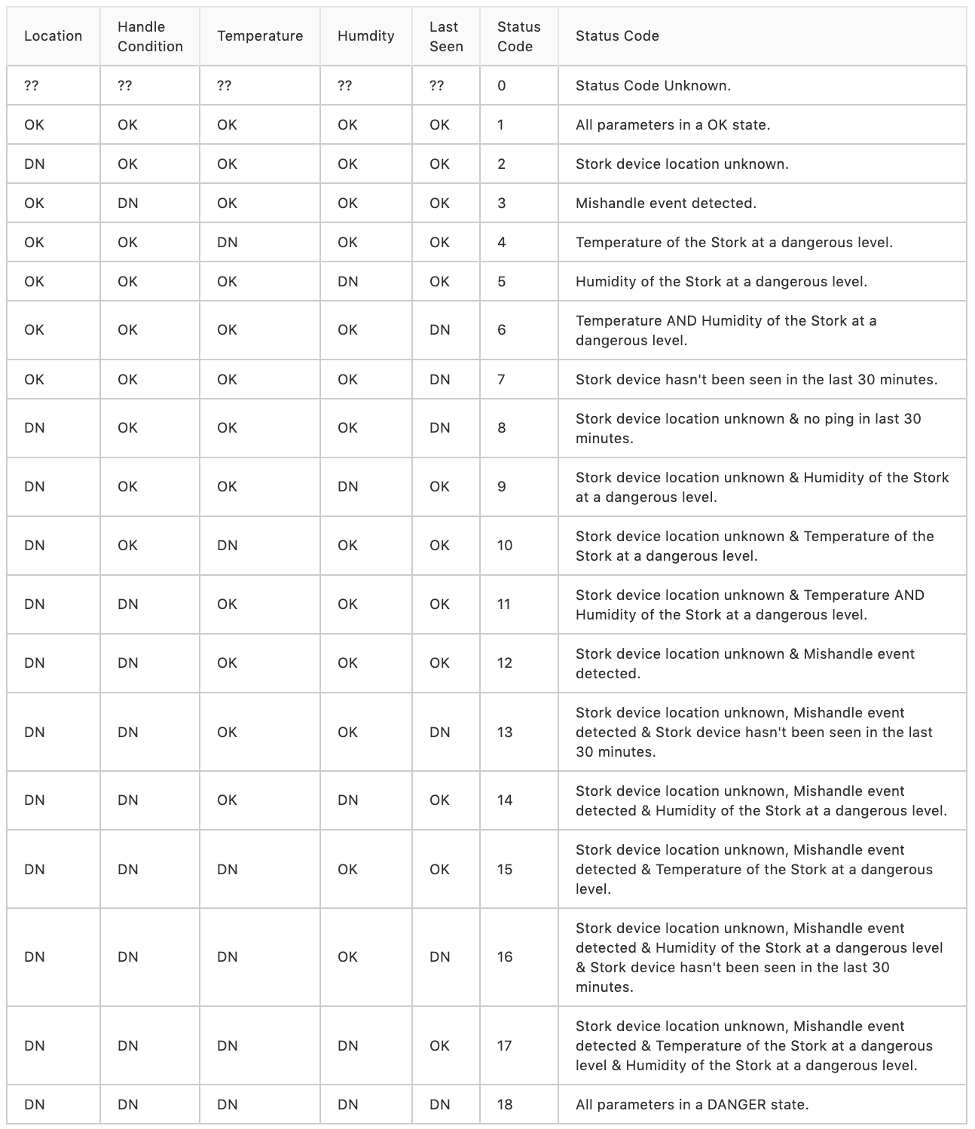

Figure 40: Stork code state table

After the status code is determined, the data is then packed into a byte array using the **struct** library. Sigfox allows up to 12 bytes to be sent over its network at a time.

For example if we have the following data:

Latitude (Lat): 52.23094

Longitude (Long): -7.3401155

Temperature (Temp): 12°C

humidity (Hum): 84%

statusCode (Stat): 4

The byte array would be packed in the following way:

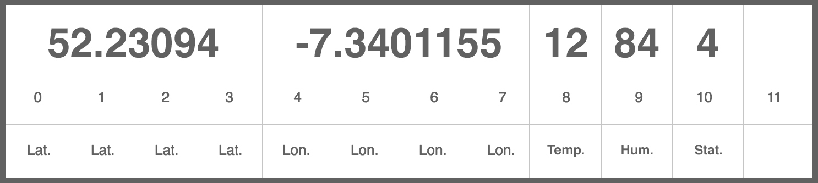

Figure 41: Example of a packed byte array sent to the Sigfox backend

The above in code:

| longByteArray = bytearray(struct.pack("<f", float(52.23094))) longByteArray.extend(bytearray(struct.pack("<f", float(-7.3401155)))) longByteArray.extend(bytearray(struct.pack("<B", 12))) longByteArray.extend(bytearray(struct.pack("<B", 84))) longByteArray.extend(bytearray(struct.pack("<B", 4))) |
| --- |

Finally this is then sent up. It only takes a few seconds for it to be sent. The Stork devices LED turns light blue while the data is being sent and then turns green when it is sent.

| s.send(longByteArray) |
| --- |

After this, the device’s timer is reset, the heartbeat is enabled and the loop starts once again.

## Stork.ie Domain.

The domain [stork.ie](http://stork.ie) was purchased from the Irish hosting company **Hosting Ireland.**

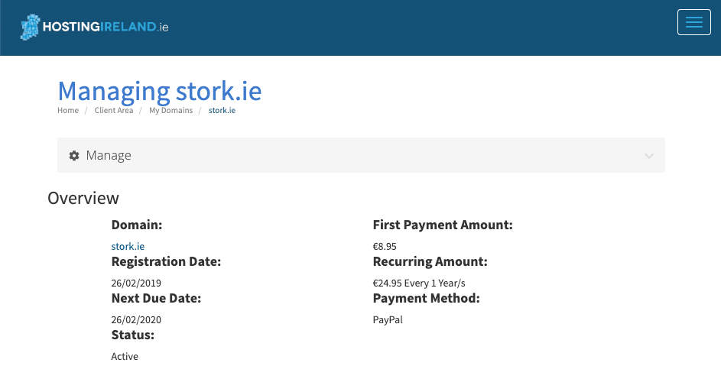

This allows a user to access the Stork Web Application from the domain [stork.ie](http://stork.ie) versus [87.44.18.111](http://87.44.18.111/). Users assume a website they are visiting always has a domain main which they can remember so Stork must match that expectation.



# SIGFOX BACKEND.

Every time a Stork device pushes data, it is sent to the Sigfox backend where a Callback can be defined. A Callback commands the Stork to forward the data to certain endpoint everytime the Sigfox backend receives data from a device.

The following section I will outline the Callback which was defined in order to send the data from the backend to the Stork web application.

## Callback Type.

The Callback type was set to a DATA UPLINK on the URL channel.

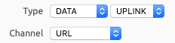

## Payload.

The Custom Payload Config was set to:

lat::float:32:little-endian lng::float:32:little-endian temp::uint:8 hum::uint:8 stat::uint:8

where:

**lat::float:32:little-endian:** a 32 bit float which reads from the left that represents the Stork device’s latitude reading;

**lng::float:32:little-endian:** a 32 bit float which reads from the left that represents the Stork device’s longitude reading;

**temp::uint:8:** an 8 bit unsigned integer that represents the Stork device’s temperature reading;

**Hum::uint:8:** an 8 bit unsigned integer that represents the Stork device’s humidity reading;

**stat::uint:8**: an 8 bit unsigned integer that represents the Stork device’s status code.

## 

## 

## 

## 

## 

## Url Pattern.

After this the Url Pattern is defined which dictates where the data is sent to. In this case it will be sent to Stork API endpoint as a PUT request which handles data being pushed from a Stork device and updates a Stork devices data in the Stork database.

Sigfox provides a number of variables, most importantly the device code (Stork code) of the device which has pushed data. These variables are used by surrounding the variable name in braces ie. {device} in this case.

http://87.44.18.111:3000/api/storks/push/{device}

Which, for example would be:

http://87.44.18.111:3000/api/storks/push/**4D2BC3**

## Callback Content.

The content type is set to application/json where the body is defined as

| {  "lastseen" : "{time}",  "device" : "{device}",  "location" : {"type" : "Point", "coordinates" : [{customData#lat}, {customData#lng}]},  "temperature" : {customData#temp},  "humidity" : {customData#hum},  "statusCode" : {customData#stat} } |
| --- |

This JSON is structured as the Stork API expects it. The above uses some more Sigfox variables along with the data which has been pushed from the Stork device using the same brace notation but prefixing the variable with **“customData#”**.

The Callback is now complete. Now when the Stork device pushes data, it can be seen in the **Messages** section (Figure 42).

## 

Figure 42: Stork callback being sent to data push api

Finally the data is consumed by the Stork backend and reflected in the Stork devices owners dashboard (Figure 43).

## 

Figure 43: Stork callback being sent to data push API

# DOCKER.

The Stork web application operates using three [Docker](https://www.docker.com/) contains which are managed using [Docker Compose](https://docs.docker.com/compose/). The use of Docker is initially difficult to set up but once everything is in place it makes testing and deployment a trivial task.

Using Docker also allows the Stork system to deployed in any system due to all the compatibility issues Docker solves.

Finally if, for example, the Stork backend needed to be hosted on a seperate server to the Stork frontend. This task again is simplified by using Docker.

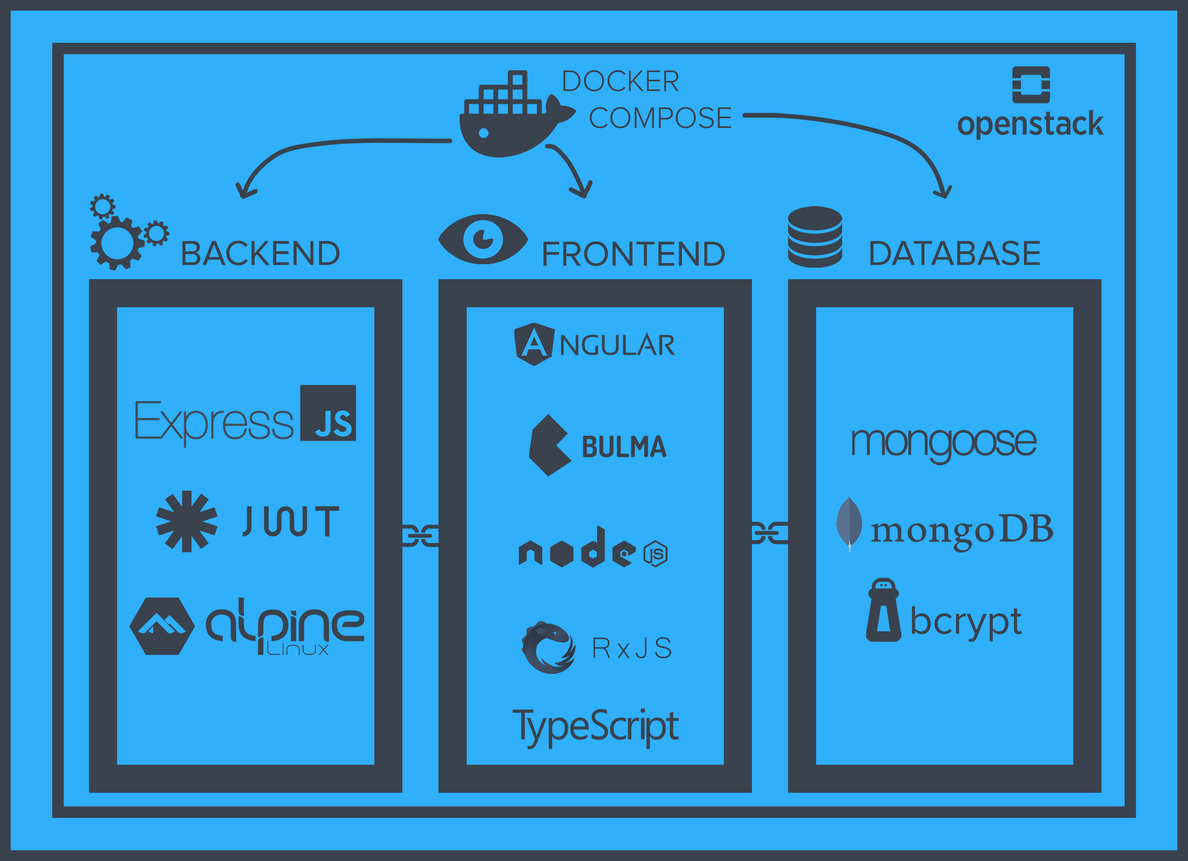

Figure 44: Stork container structure diagram

## Docker Compose.

These docker containers are configured in the **docker-compose.yml** [file](https://gitlab.com/stork-group/stork-web-service/blob/dev/docker-compose.yml) at the root of the Stork project. In the following section this file will be walked through (additional notes in comments of the code snippets):

The docker compose version is first defined.

| version: "3.0" |
| --- |

Containers are defined in the “services”section.

## Frontend Container.

Firstly, the **frontend** container is first defined.

| services:  frontend:  # Point to the frontend directory to build from.  build: frontend  # Map the port for the frontend for nginx.  ports:  - "80:80" |
| --- |

This **build** field points to the [frontend Dockerfile](https://gitlab.com/stork-group/stork-web-service/blob/dev/frontend/Dockerfile):

The frontend container is built using an image based on the official [Node 8.9.0 image from Dockerhub](https://hub.docker.com/_/node/).

| FROM node:8.9.0 as node |
| --- |

After the node image is pulled from Dockerhub, a directory is created where the Stork application will be placed.

| RUN mkdir -p /stork |
| --- |

The working directory is then changed so commands to follow, run inside this new directory.

| WORKDIR /stork |
| --- |

Place the package.json file so the node packages can be installed.

| COPY package.json /stork |
| --- |

Install these packages

| RUN npm install |
| --- |

After this we can move our full application folder over

| COPY . /stork |
| --- |

Expose the Angular port which the app runs on

| EXPOSE 4200 |
| --- |

Command Angular to build the Stork web application

| RUN npm run build |
| --- |

We now to serve the Angular static files, this is done using [Nginx](https://www.nginx.com/). The Alpine Nginx image based is pulled and built.

| FROM nginx:1.13.7-alpine |
| --- |

Remove the default Nginx website and replace it with the Stork static file.

| RUN rm -rf /usr/share/nginx/html/* COPY --from=node /stork/dist/stork /usr/share/nginx/html |
| --- |

Copy the Nginx configure file

| COPY ./nginx-stork.conf /etc/nginx/conf.d/default.conf |
| --- |

Expose port 80 for Nginx and start Nginx.

| EXPOSE 80 CMD ["nginx", "-g", "daemon off;"] |
| --- |

## Backend Container.

Secondly, the **backend** container is defined.

| backend:  # Point to the backend directory to build from.  build: backend  # Expose and link the port for the backend.  ports:  - "3000:3000"  # Link the backend to the database container which will  # allow the backend to connect to the database.  links:  - database |
| --- |

This **build** field points to the [backend Dockerfile](https://gitlab.com/stork-group/stork-web-service/tree/dev/backend):

The frontend container is built using an image based on the official [Node 8.15.0 Alpine Image from Dockerhub](https://hub.docker.com/_/node/).

| FROM node:8.15.0-alpine |
| --- |

After the node image is pulled from Dockerhub a directory is created where the Stork’s backend will be placed.

| WORKDIR /usr/src/app |
| --- |

Place the package.json file so the node packages can be installed. A wildcard is used to ensure both package.json **and** package-lock.json are copied where available.

| COPY package.json /stork |
| --- |

Install these packages.

| RUN npm install |
| --- |

Move the everything from the backend.

| COPY . . |
| --- |

Expose the port which our server listens on.

| EXPOSE 3000 |
| --- |

Start the node server

| CMD [ "npm", "start" ] |
| --- |

## Database Container.

Finally, the **database** container is defined.

This is very simple task as the Stork system uses a pre built MongoDB image. There is no need to create a Dockerfile, all that's needed is to expose the **4200** port in our docker-compose file to allow the backend container to connect with it (Figure45) .

| database:  image: mongo  ports:  - "27017:27017" |
| --- |

To access the MongoDB CLI, ssh into the database container using

| docker exec -it stork-web-service_database_1 bash |
| --- |

And then issuing the **mongo** command.

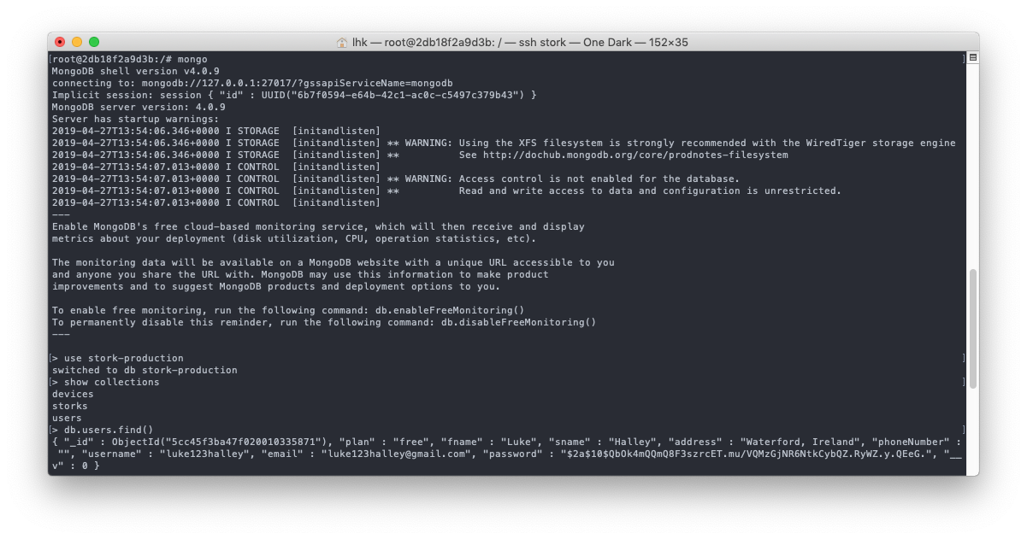

Figure 45: Accessing the Stork MongoDB database in its container

## 

## Makefile Usage.

At the root of the Stork web application directory there is a single [Makefile](http://www.cs.colby.edu/maxwell/courses/tutorials/maketutor/) which allows these three containers to be easily managed.

| # Full clean slate build of the Stork system. build:  # Delete all containers.  docker rm -f $(docker ps -a -q)  # Delete all images.  docker rmi -f $(docker images -q)  # Build the Stork system.  docker-compose build  docker-compose up --force-recreate  # Rebuild the system to apply changes. rebuild:  # Build the Stork system.  docker-compose build  docker-compose up --force-recreate  # Teardown the whole Stork system. teardown:  docker volume rm $(docker volume ls -qf dangling=true)  docker volume ls -qf dangling=true | xargs -r docker volume rm |
| --- |

Where:

* build: Creates the Stork system from scratch, removing any old containers which exist;
* rebuild: Rebuild the Stork system to apply changes;
* teardown: Removes all containers.

The above file can be ran by executing the following (-i flat to ignore errors in the teardown stage if containers do not exist).

| # Full “clean slate” build of the Stork system.  make -i build  # Rebuild the system to apply changes.  make -i rebuild  # Teardown the whole Stork system.  make -i teardown |
| --- |

## 

# DEPLOYMENT.

As a result of using Docker partnered with a [Makefile](http://www.cs.colby.edu/maxwell/courses/tutorials/maketutor/), it would be straight forward for a developer to get a Stork system up and running.

Note: The following assumes a unix system (specifically Ubuntu 18.04, but this should not matter) is being used.

First **Docker** and **Docker Compose** must be installed ([tutorial](https://docs.docker.com/compose/install/) from the Docker docs);

**Make** must be then installed (follow the following [instructions](https://linuxconfig.org/how-to-install-gcc-the-c-compiler-on-ubuntu-18-04-bionic-beaver-linux));

Clone the [stork-web-service](https://gitlab.com/stork-group/stork-web-service).

| git clone git@gitlab.com:stork-group/stork-web-service.git |
| --- |

Finally simply run the following command to at the root of Stork directory

| Make build |
| --- |

After the build has finished, simply visit the IP address of the Ubuntu server and a fully functional version should be available for use (Figure 46).

## 

Figure 46: Stork landing page

# TESTING.

A set of extensive end to end UI tests was developed to test the Stork system. These tests were created using [TestCafe](https://devexpress.github.io/testcafe/) (Figure 47). TestCafe is a powerful node.js tool used to automate end-to-end web testing. The tests are written and run in Javascript. A report of the test results is returned quickly and clearly. All tests are contained in the [test directory](https://gitlab.com/stork-group/stork-web-service/tree/dev/test) at the root of the Stork repository.

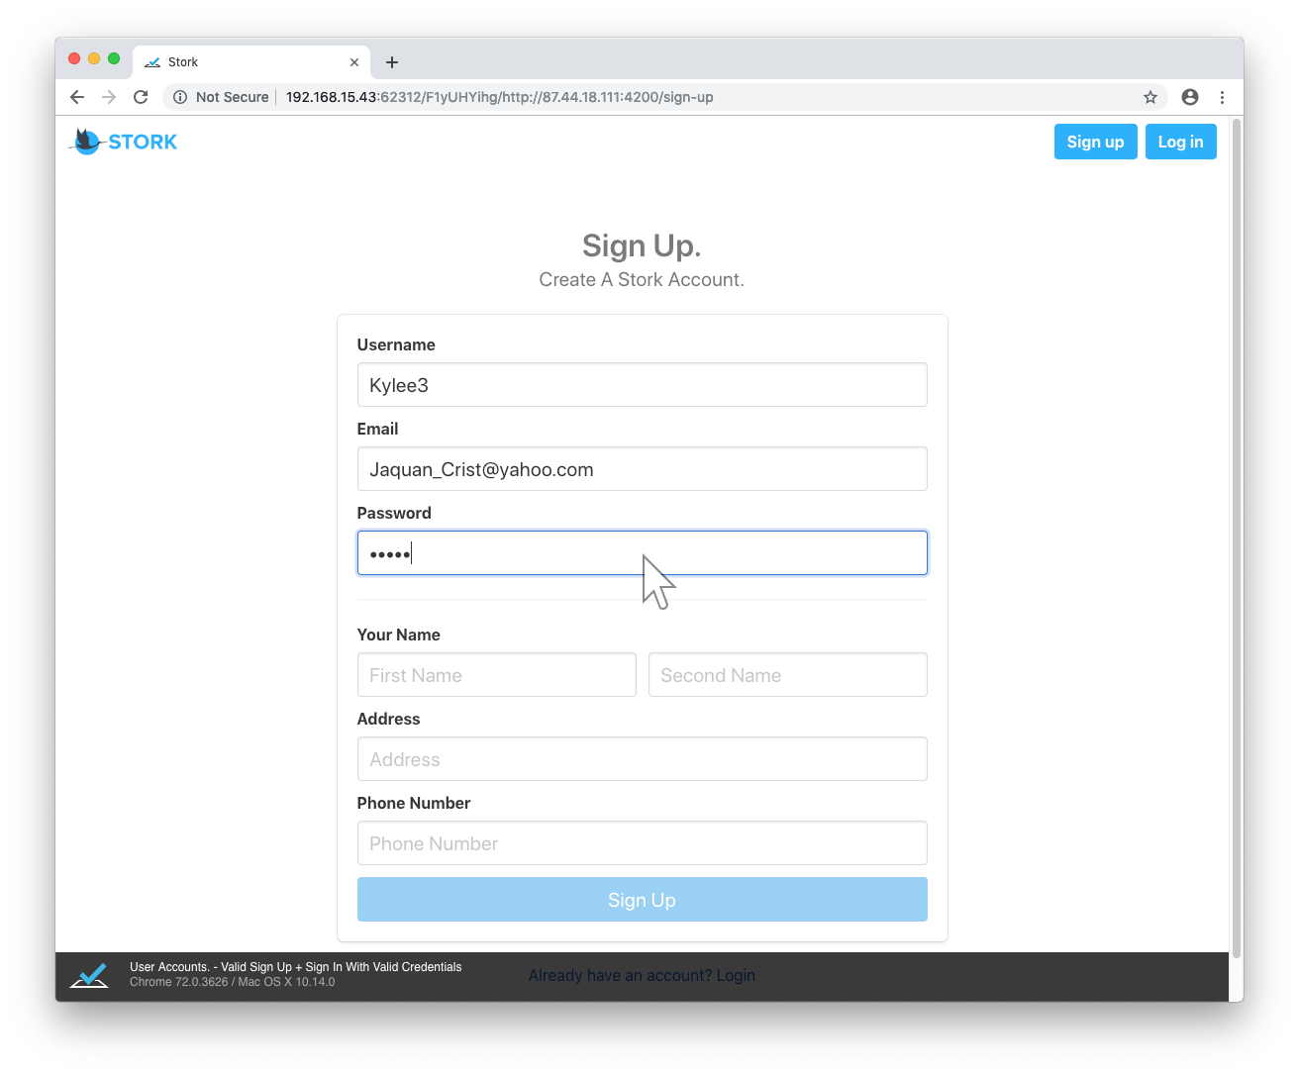

Figure 47: Testcafe testing the Stork register form

## 

## Implementation.

In the following section one example of a Stork will be outlined. This example is a test which involves the following:

* Before All;
* Add a registerable Stork Device;
* Register for a Stork user account;
* Login to the Stork account that was just created;
* Register that Stork Device we just made registerable;
* Edit the Nickname of that Stork Device;
* Logout of the Stork account that we created;
* Make the Stork Device unavailable for registration once again.

### **Setup.**

All the libraries needed to run the following tests are imported.

| import { Selector } from 'testcafe'; import { ClientFunction } from 'testcafe'; |
| --- |

And a the [Faker JS](https://www.npmjs.com/package/faker) node module which generates the fake data is used as credentials for the users which are being signed up during these tests. Fakers functionality will be shown later in this section.

| import * as faker from 'faker'; |
| --- |

In order to add and remove registerable Stork Devices, [two helpers](https://gitlab.com/stork-group/stork-web-service/blob/dev/test/helpers/test-helpers.ts) were created which allowed the tests to send HTTP requests using the [axios](https://www.npmjs.com/package/axios) node module.

| import axios from 'axios';  const createUrl ='http://87.44.18.111:3000/api/devices/admin/available-device/add/';  const deleteUrl ='http://87.44.18.111:3000/api/devices/admin/available-device/delete/';  export async function addDevice(code) {  return axios  .post(createUrl, {  dev_code: code,  available: 'true',  ownerId: null  })  .then(function(response) {  console.log('Device REGISTER Successful');  })  .catch(function(error) {  console.error('Device REGISTER Unsuccessful!');  }); }  export async function remDevice(code) {  return axios  .delete(deleteUrl + code, {  params: { foo: 'bar' }  })  .then(function(response) {  console.log('Device DELETE Successful');  })  .catch(function(error) {  console.log(  'Device DELETE Unsuccessful! (More than likely the device does not exists)'  );  }); } |
| --- |

A simple function was created to get the browsers current URL.

| const getLocation = ClientFunction(() => document.location.href); |
| --- |

Faker JS is then used to create a number of both valid and invalid credentials.

| const fNameValid = faker.name.firstName(); const emailValid = faker.internet.email(); ... const addressInvalid = faker.address.streetAddress(); const phoneInvalid = faker.phone.phoneNumber(); |
| --- |

For example:

| faker.name.firstName();  faker.internet.email(); |
| --- |

Will generate a first name like Joe, Luke etc and an email like joesuper@mail.com.

After a large amount of variables are created which contain the [CSS Selectors](https://www.w3schools.com/cssref/css_selectors.asp) for all the elements TestCafe needs to perform clicks on, read from etc.

For example here is the selector for the register button which exists in the Stork web applications navigation bar:

| const registerNavButton = 'div#storkNavbar a:nth-child(2)'; |
| --- |

Will be used to click this button

| .click(registerNavButton) |
| --- |

## 

### **Add Registerable Device.**

Just in case the test device is registered I remove it as a registered device and register it once again using the helpers mentioned above.

| // Remove the device just in case it exists await remDevice(storkId); // Add the device await addDevice(storkId); |
| --- |

### **User Signup Test.**

Testcafe is first told to click the 'Don't have an account? Sign Up' button. After this, the browser is brought to the sign up page, where the credentials created by Faker JS are entered into the fields. After the fields are filled, the user is registered by clicking the signup button. Finally TestCafe checks if the registration has been successful. This is done by checking the browsers current URL when a user registration has been successful they are navigated to the **/login** route.

| await t  // Click the 'Don't have an account? Sign Up'  .click(signUpPromptUnderLogin)   // Fill in the fields of the user  .typeText(usernameField, usernameValid)  .typeText(emailField, emailValid)  ...  .typeText(phoneNumberField, phoneValid)   // Create user, should be brought to the sign in page.  .click(signupSubmitButton)  .expect(getLocation())  .contains('/login') |
| --- |

### **User Login Test.**

The tests then sign in to the account that was just created. TestCafe then checks if the log in has been successful. This is done by checking the browsers current URL as when a user login has been successful they are navigated to the **/storks/your-storks** route.

| // Sign in with the details.  .typeText(emailField, emailValid)  .typeText(passwordField, passValid)  .click(loginSubmitButton)   // If the sign in went correctly you should be brought to the list of the users Storks.  .expect(getLocation())  .contains('/storks/your-storks') |
| --- |

## 

### **Stork Register Test.**

Now that the test user is logged in a Stork device can be registered. This is done by first clicking the **“Register A Stork”** located in the navigation bar. TestCafe then checks the current URL as well as the pages title, to make sure the browser has been navigated to the Stork registration page. The Stork Code that was registered using the helpers is entered and a Nickname is entered. The Stork is then registered by pressing the “**Add”** button. To ensure the Stork was registered successfully, TestCafe ensures the Nickname and Stork Code that was given to the device exists on the tracking page.

| // Click the register button in the navbar.  .click(registerNavButton)  .expect(getLocation())  .contains('/storks/register-stork')  // The title should say 'Register Your Stork.'  .expect(Selector(storkTitle).withExactText(addStorkTitle).exists)  .ok()  // Enter the Stork details - storkId and storkNickname.  .typeText(inputStorkID, storkId)  .typeText(inputStorkNickname, storkNickname)  .expect(Selector(addStorkButton).textContent)  .contains('Add')  .click(addStorkButton)  .expect(getLocation())  // If the Stork register goes correctly the user should be brought to the list of the  users Stork list.  .contains('/storks/your-storks')  // The details the user just entered should be seen on the first card.  .expect(  Selector(firstStorkListCardNickname).withExactText(storkNickname).exists  )  .ok()  .expect(Selector(firstStorkListCardStorkCode).withExactText(storkId).exists)  .ok() |
| --- |

## 

### **Stork Edit Test.**

The **“Edit”** button of the Stork device that was just created is then pressed. TestCafe checks that the URL contains the substring **/storks/edit/** to make sure the browser is on the edit page of the Stork that the test aims to change the details of. The title of the page is checked as another layer of testing. The details are changed, the **“Save”** button is pressed and TestCafe ensures the details of the Stork has been changed.

| // Click the edit button on the first Stork card.  .click(editStorkButton)  .expect(getLocation())  // The user should be brought to the edit page.  .contains('/storks/edit/')  // Check the Sublist of the users current Storks  .expect(  Selector(firstStorkListCardNickname).withExactText(storkNickname).exists  )  .ok()  .expect(Selector(firstStorkListCardStorkCode).withExactText(storkId).exists)  .ok()  // Check the title, it should be 'Edit Your Stork.  .expect(Selector(storkTitle).withExactText(editStorkTitle).exists)  .ok()  // Clear the text from the nickname field.  .click(inputStorkNickname)  .pressKey(selectAllAndDeleteField)  .typeText(inputStorkNickname, storkNicknameEdit)  // Save the Stork by pressing the Save button  .expect(Selector(saveStorkButton).textContent)  .contains('Save')  .click(saveStorkButton)  .expect(getLocation())  .contains('/storks/your-storks')  .expect(  Selector(firstStorkListCardNickname).withExactText(storkNicknameEdit)  .exists  )  .ok() |
| --- |

### **Stork Delete Test.**

The **“Edit”** button of the Stork device that was just edited is then pressed. TestCafe checks that the URL contains the substring /storks/edit/ to make sure the browser is on the edit page of the Stork that the test aims to change the details of. The title of the page is checked as another layer of testing. The “**Delete**” button is then clicked for the Stork device

| // Click the edit button on the first Stork card.  .click(editStorkButton)  .expect(getLocation())  // The user should be brought to the edit page.  .contains('/storks/edit/')  .click(deleteStork) |
| --- |

## 

### **User Logout Test.**

The test user is then logged out by clicking the “**Logout**” button located in the navigation bar. TestCafe checks the logout has been successful if the current URL of the browser is **/login** as a user is navigated here when they logout.

| .click(logoutButton)  .expect(getLocation())  .contains('/login'); |
| --- |

### **Remove Registered Device.**

Finally the test Stork Device which was registered at the start of the test is removed as a registered device. This is done to set up a clean slate for the next time the Stork web application is tested.

| await remDevice(storkId); |
| --- |

# 

## Running Tests Using Gitlab Continuous Integration.

During the development, the above tests were tested using Chrome with a GUI but having to run the tests a desktop is not practical. Fortunately, TestCafe can run its tests using headless browser, to this end, [Chromium Headless](https://chromium.googlesource.com/chromium/src/+/lkgr/headless/README.md) was used.

This does improve the process of testing but TestCafe still needs to be ran manually, this is where [GitLab Continuous Integration](https://about.gitlab.com/product/continuous-integration/) comes in (more on the use of [GitLab](https://about.gitlab.com/) in the next section)

TestCafe provides a Docker [container image](https://hub.docker.com/r/testcafe/testcafe/) which can be used by GitLab CI tool:

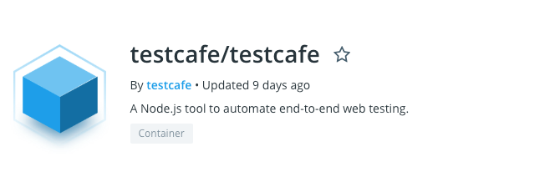

Figure 48: Testcafe image on Docker hub

GitLab CI is configured using a [gitlab-cli.yml](https://gitlab.com/stork-group/stork-web-service/blob/dev/.gitlab-ci.yml) file placed at the root of the repository

| ui-tests:  image:  name: testcafe/testcafe  entrypoint: ['/bin/sh', '-c']  script:  - npm install axios  - npm install faker  - /opt/testcafe/docker/testcafe-docker.sh "chromium:headless" test/test-ui.ts |
| --- |

The above pulls the TestCafe image from Docker Hub and sets the entry point to bash. After this the additional packages are installed which are needed to perform the tests. Finally the tests are then executed using Chromium Headless.

These tests run everytime code is pushed to the Stork Web Service Gitlab. This allows me to quickly make sure the code I have written is correct and does not create problems with the existing code in the repository.

Tests results can be seen in the [**Pipelines**](https://gitlab.com/stork-group/stork-web-service/pipelines)section of GitLab (Figure 49).

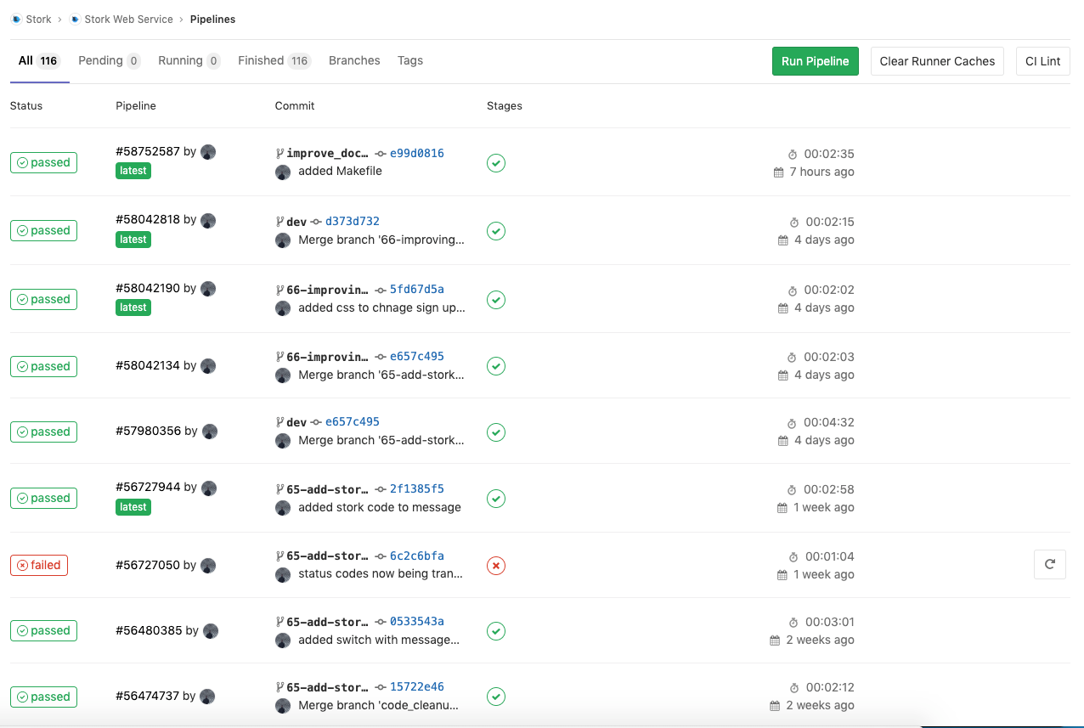

Figure 49: Stork CI pipelines

You can see the commit which the pipeline is associated with and how long it took to run.Clicking on the “**Status”** for a individual test and again clicking into the “**UI Tests**” section will display the log of the test (Figure 50).

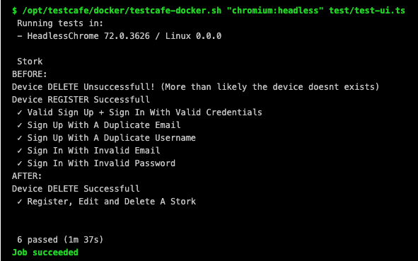

Figure 50: Successful Stork UI tests

This is useful for when tests fail, these logs display TestCafe’s logs which are very easy to read which allows the problem which occured to be quickly found and resolved

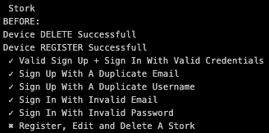

Figure 51: Testcafe reporting the tests which passed and failed

Its clear to see that the registration test failed, indicated by the cross (Figure 51).

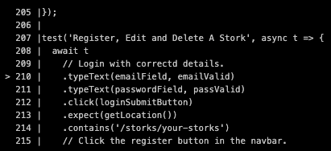

Figure 52: Testcafe reporting the tests where the tests failed

Using an arrow, TestCafe shows when it tried to type the email into the login field (Figure 52).

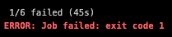

Figure 53: Testcafe reporting how many tests passed and failed

This test would have indicated the registration of the test user had not worked. It can be assumed the browser did not navigate to the login page after registration, as a result, the user could not type the email into the login field.

Emails are also sent whenever a pipeline fails so a developer is prompted that there is code which needs to be fixed (Figure 54).

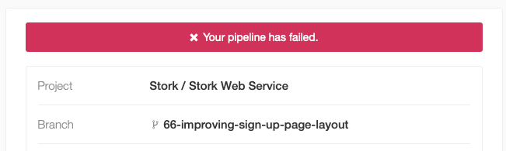

Figure 54: Pipeline failure email

Finally these tests add another layer of protection when merging branches into the development branch. Before any code can be merged into dev, the Stork UI tests are run against the branch which has been request to be merged (Figure 55).

# 

Figure 55: Manual branch merging on pipeline success

As a project with only a single member working on it, the end to end continuous integration tests act as a second second developer who would normally be sent a merge request(Figure55).

Branches can also be a automatically when the pipeline succeeds (Figure 56).

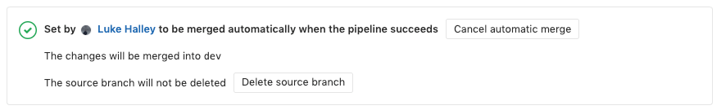

Figure 56: Automatic branch merging on pipeline success

# PROJECT MANAGEMENT.

The entity of the Stork system was managed using [GitLab](https://about.gitlab.com/). GitLab is a development and operations web application. It provides a Git repository, a wikipedia, issue-tracking and CI/CD pipeline features as shown in the **Testing** section.

The Stork GitLab group can be found here: <https://gitlab.com/stork-group>

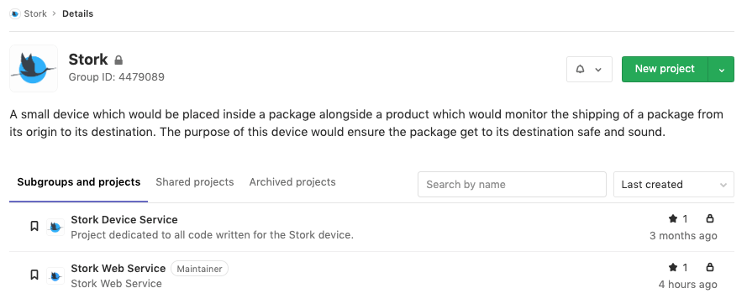

Figure 57: Stork GitLab group

In the Stork group, the Stork system was split into two separate projects:

**Stork Web Service.**

The [Stork Web Service project](https://gitlab.com/stork-group/stork-web-service) (Figure 58) contains all resources for the Stork web application.

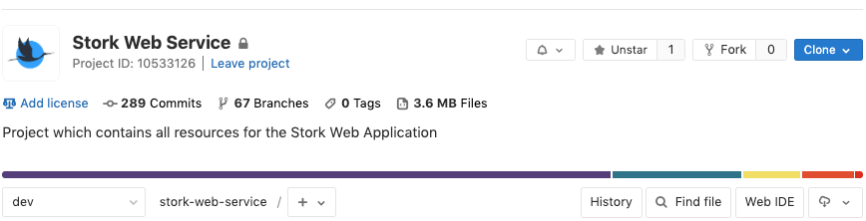

Figure 58: Stork web service project

**Stork Device Service.**

The [Stork Device project](https://gitlab.com/stork-group/stork-device-service) (Figure 59) contains all resources for the Stork device.

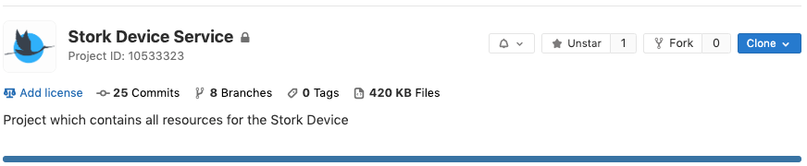

Figure 59: Stork device service project

Both above projects were managed in parallel and in the same fashion. To demonstrate how the both projects were managed using the toolset GitLab offers, the Stork Web Service project will be outlined in the following section.

## Issues.

In the Stork project, issues were used to track features or tasks which needed to be completed. The following would typically occur on any given issue created as part of Stork:

* Discussion on the implementation of a new feature;
* Tracking the status of tasks, what is done, what needs to be done etc.;
* Bug reports or fixes;
* Rough ideas as to how the feature or task will assist in the completion of a task.

At the start of the development cycle, I created an issue template to ensure issues were written in a consistent format (Figure 60).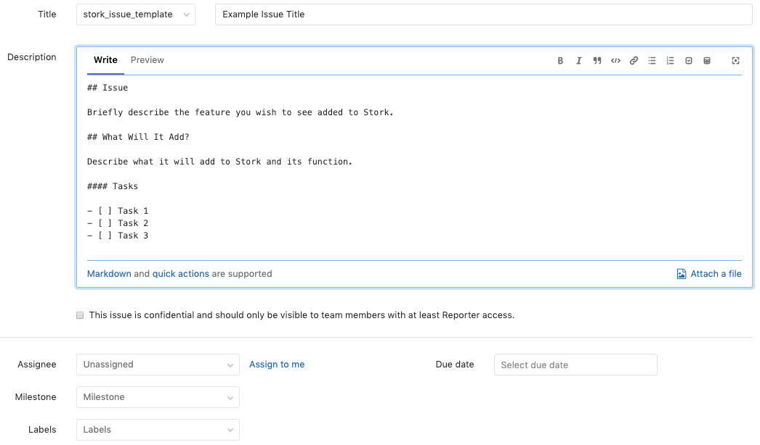

Figure 60: Stork issue template

Below is an example of a real issue (which can be found [here](https://gitlab.com/stork-group/stork-web-service/issues/45)) created to add a message to tell a user they had no Stork devices registered to their account (Figure 61).

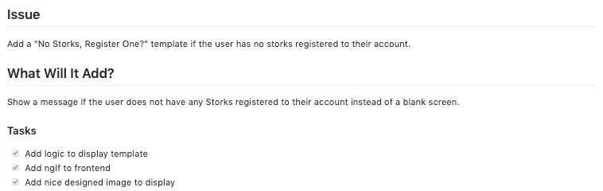

Figure 61: Example of a Stork issue

GitLab issue manager also:

* Associates branches created to address the issue;
* Automatically closes issues when their associated branch is merged;
* Tracks if all tasks listed in the issue have been completed (Figure 62).

These features can be seen for the above issue:

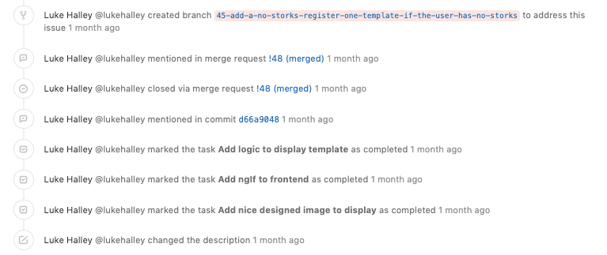

Figure 62: Stork issue events

## Iterations.

The Stork system was developed using the Agile development methodology. During the Stork development cycle, work was confined to a repeating and regular sprint, also known as an iteration. These sprints were two weeks long. At the start of each week, a list of the issues which need to be completed would be placed in the iteration (Figure 63).

These two week iterations, along with the issues, were tracked and managed in the “**Milestones**” section in GitLab.

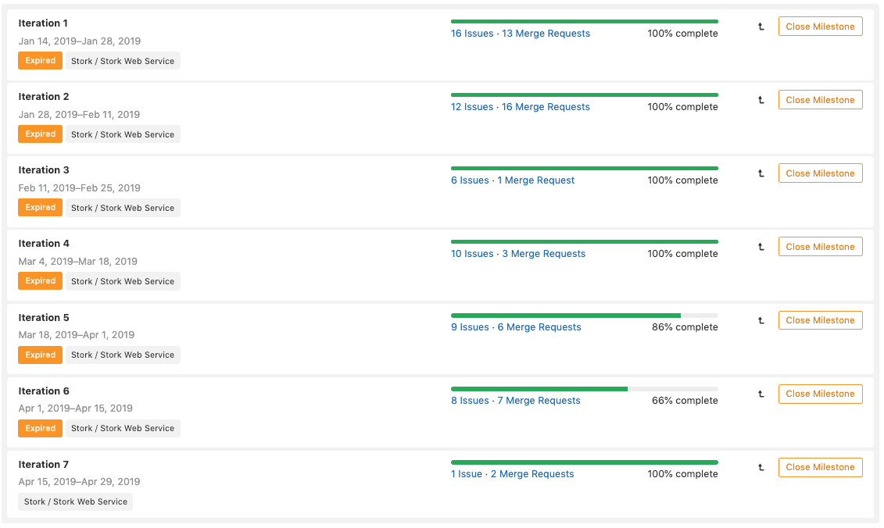

Figure 63: Stork issue template

Issues were also created during iterations and added to the current iteration. This happened when there was a need for new feature to be added or when an issues that arises to be resolved.

More information about any given iteration can be seen by clicking the iteration in the “**Milestones**” section. For example this is [Iteration 6](https://gitlab.com/stork-group/stork-web-service/milestones/6) (Figure 64).

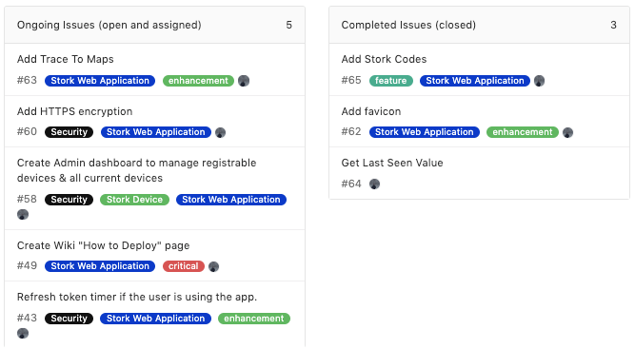

Figure 64: Iteration 6 detail view

The view shows the issues which needed to be completed and the issues which were completed.

All merge requests for that given iteration can also be seen in the **“Merge Requests”** tab (Figure 65).

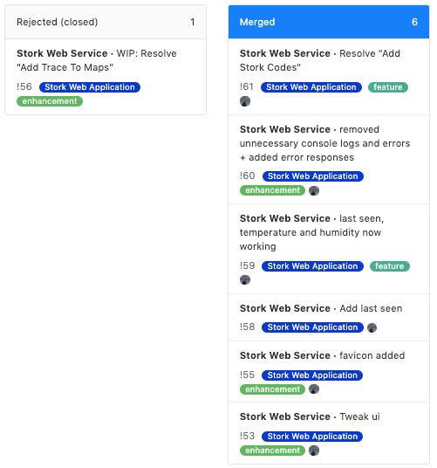

Figure 65: Iteration 6 merge requests

# 

## Tags.

GitLab allows issues and merge requests to be marked with tags (Figure 66).

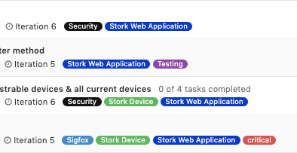

Figure 66: Use of tags in Issues

During the first iteration, I created a number of tags which allowed me to quickly find all issues relating to a certain topic (Figures 67 and 68).

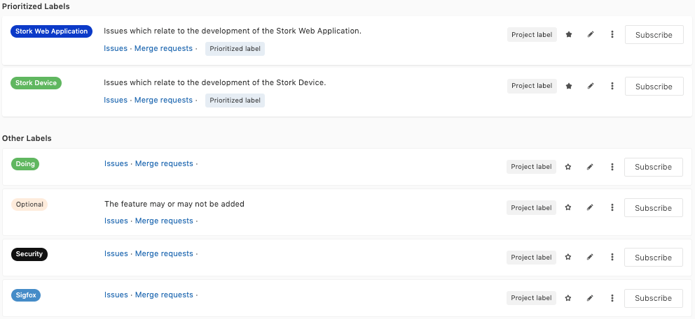

Figure 67: Tags created

For example if the Sigfox label all issues relating to Sigfox can be seen.

# 

Figure 68: Stork project tags

## 

## Stork Wiki.

GitLab allows a project to have its own personal wikipedia, which stores information relating to the project.

There is a wiki for both Stork projects (Figure 69 and 70). These contain setup instructions, details about the technology used etc. Please find the links to the wiki’s below.

[Stork Web Service Wiki](https://gitlab.com/stork-group/stork-web-service/wikis/Stork-Web-Service-Wiki)

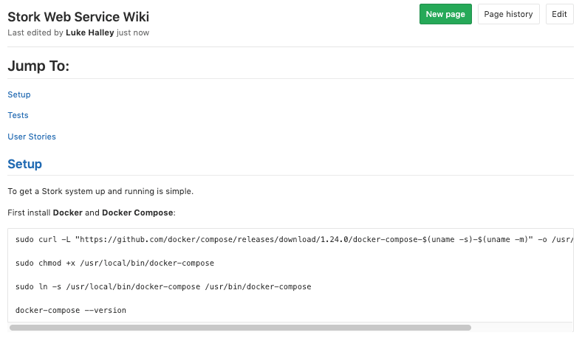

Figure 69: Stork Web Service Wiki

[Stork Device Wiki](https://gitlab.com/stork-group/stork-device-service/wikis/Stork-Device-Wiki)

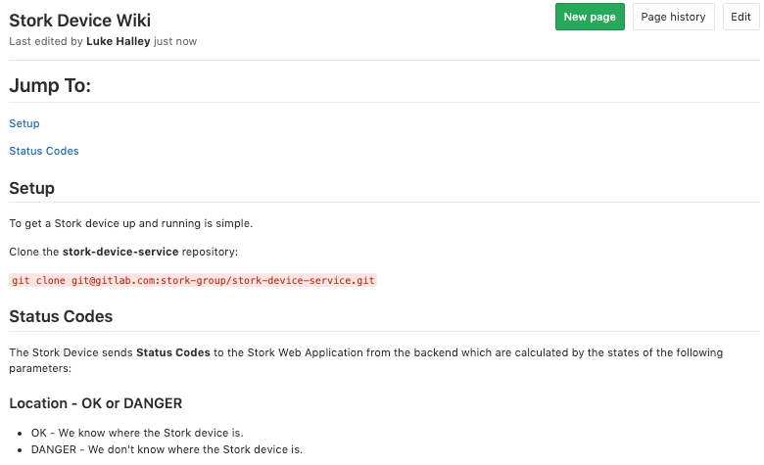

Figure 70 : Stork Device Wiki

# 

# VERSION CONTROL.

During the development cycle of the Stork system, an industry standard approach to version control was carried out. A large feature set and good practices of Git was used during the cycle, these will be listed and described in the following section.

## Regular Commits.

Code was regularly pushed to the Stork project repositories during development. This was mainly to avoid adding code poorly thought out, with no way to restore the working version. Additionally, having periodic checkpoints allowed me to understand how something was broken and easily reverted.

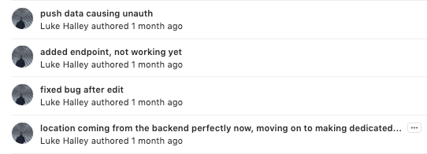

Figure 71: Stork Regular Commits

## Meaningful Commit Messages.

Detailed commits were used when pushing code to ensure during future development, a developer could see how the project was built step by step and why certain sections were added (Figures 72 and 73).



Figure 72: Stork Meaningful Commit Messages

## Development Branch.

To ensure all code which resides on the **master** branch is production level, a **development** branch was created and set as the default branch. This sets it as the default branch code is merged to if not specified otherwise.

The dev branch (Figure 73) is also protected, all code on the development code must at least run without any errors. All code which is being proposed to be merged into the development branch must be merged using a **merge request.** This ensures the code being merged works and meets the standards of the Stork system.

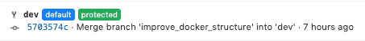

Figure 73: Stork Development Branch

## Feature Branches.

Each feature which is required to be added to the Stork system has a corresponding branch (Figure 74) and issue. A full list of the Stork Web Services branches can be found [here](https://gitlab.com/stork-group/stork-web-service/branches/all).

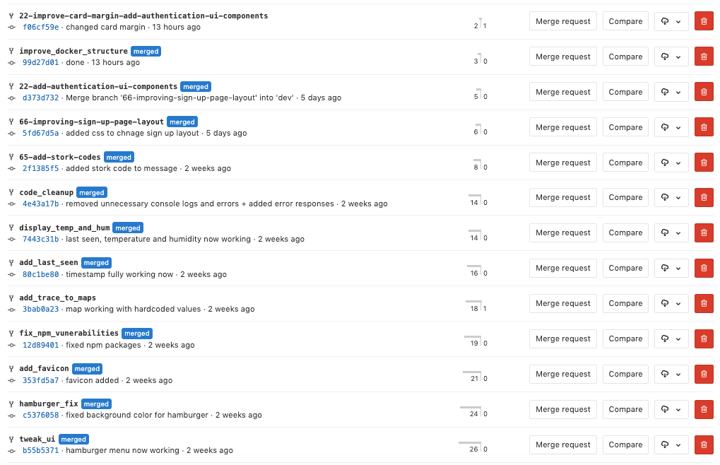

Figure 74: Stork Feature Branches

# CHALLENGES.

## Testing & Running Code On The Stork Device.

One of the most valuable lessons learned early on in the development cycle, related to using **Pymakr** and how to safely run code on a Stork device. Initially, the code to be run on the board would be placed in the main.py file and uploaded to the device. This caused no issue until code was uploaded onto the board which then resulted in an error. The problem was that everytime the device would power on and boot, it would run the faulty code which would always result in an error. While there are methods that can be used to interrupt code running on a Pycom device and flash working code back onto it, in order to restore it back to its working fashion, these methods can be difficult to apply. The reason for this, is that the window of time between the device booting and running the code is quite small.

The solution is to create a separate python file, in my case stork.py, and using the **Run** function of the Pymakr REPL console. This runs the python file on the device but does not upload it. This allows testing of code without the risk of leaving the device unusable.

## Laying Out The Stork Web Application.

It took a great deal of wireframing and experimentation in order to get the Stork Web Application to a point where it was easy to use in addition to being modern and well designed.

## Learning How To Implement JWT.

Due to it being the first contact with JSON web tokens it was quite challenging to implement initially. After a couple of times stepping through the [documentation](https://www.npmjs.com/package/jsonwebtoken), it was understood and implemented.

**Serving Static Files With NGINX & Docker.**

Switching from developing locally to Docker, required a new way to serve the Angular JS static files. This wasn’t a problem until the near end of the development cycle so it did not get in the way of the more important features but it was a challenge nonetheless.

# CONCLUSION.

The aim of this final year project was to create an IoT monitoring system. This system was to be designed such that an end user could track and monitor a parcel at all times from dispatch right through to delivery. The user would be able to access information relating to the parcel via a web application.

Technologies such as RXJS, Docker, GitLab Continuous Integration with TestCafe, JSON Web Tokens and mishandle detection were implemented in order to create this cutting edge system. While the complexity of Stork together with its large feature set posed numerous challenges, a fully functioning system was developed.

Potential for further development could include:

* the design and creation of a tailor made Stork micro controller;
* parameters set by the user via downlink to the Stork device;
* push notifications to end users.